**Customer Churn Analysis**



Author : ***Pankaj Suryawanshi***

**Topics covered:**

1. Problem Definition II. Data Analysis

III. EDA Concluding Remark IV. Pre-Processing Pipeline

V. Building Machine Learning Models VI. Concluding Remarks.

* + - * **What Is Customer Churn?**

Customer churn is the percentage of customers that stopped using company's product or service during a certain time frame.

* **Why Is Customer Churn Rate Important?**

An [increase in customer retention](http://www2.bain.com/Images/BB_Prescription_cutting_costs.pdf) of just 5% can create at least a 25% increase in profit. This is because returning customers will likely spend [67% more](http://www2.bain.com/Images/Value_online_customer_loyalty_you_capture.pdf) on company's products and services. As a result, company can spend less on the operating costs of having to acquire new customers.

* **How to Calculate Churn Rate?**
  1. Determine a time period: monthly, annual, or quarterly.
  2. Determine the number of customers we had at the beginning of the time period.
  3. Determine the number of customers that churned by the end of the time period.
  4. Divide the number of lost customers by the number of customers we had prior to the churn.
  5. Multiply that number by 100.
* **Formula:**

Customer Churn Rate = (Lost Customers ÷ Total Customers at the Start of Time Period) x 100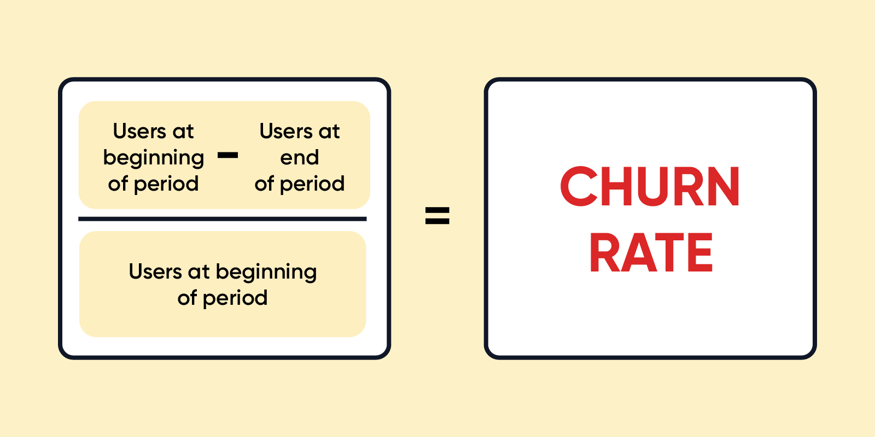

1. **Problem Definition**

Customer churn is when a company’s customers stop doing business with that company. Businesses are very keen on measuring churn because keeping an existing customer is far less expensive than acquiring a new customer. New business involves working leads through a sales funnel, using marketing and sales budgets to gain additional customers. Existing customers will often have a higher volume of service consumption and can generate additional customer referrals.

Customer retention can be achieved with good customer service and products. But the most effective way for a company to prevent attrition of customers is to truly know them. The vast volumes of data collected about customers can be used to build churn prediction models. Knowing who is most likely to defect means that a company can prioritise focused marketing efforts on that subset of their customer base.

Preventing customer churn is critically important to the telecommunications sector, as the barriers to entry for switching services are so low.

Here we are examining customer data from IBM Sample Data Sets with the aim of building and comparing several customer churn prediction models.



* 1. **Data Analysis.**
* **First thing before analysis is to import necessary libraries**

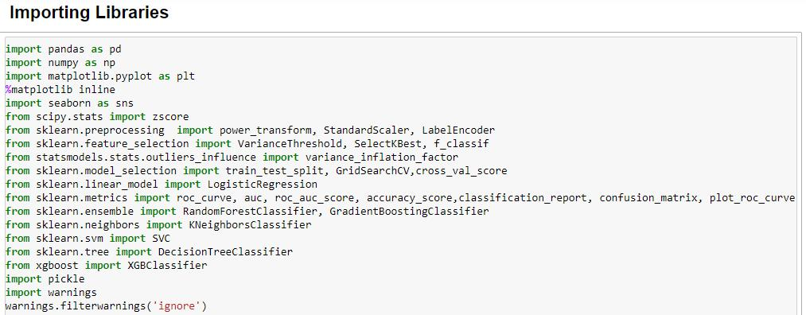

* 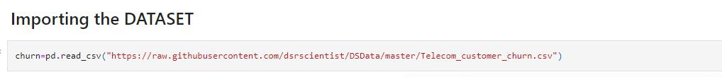**Second for analysis import Dataset (Telecom_customer_churn.csv)**
* 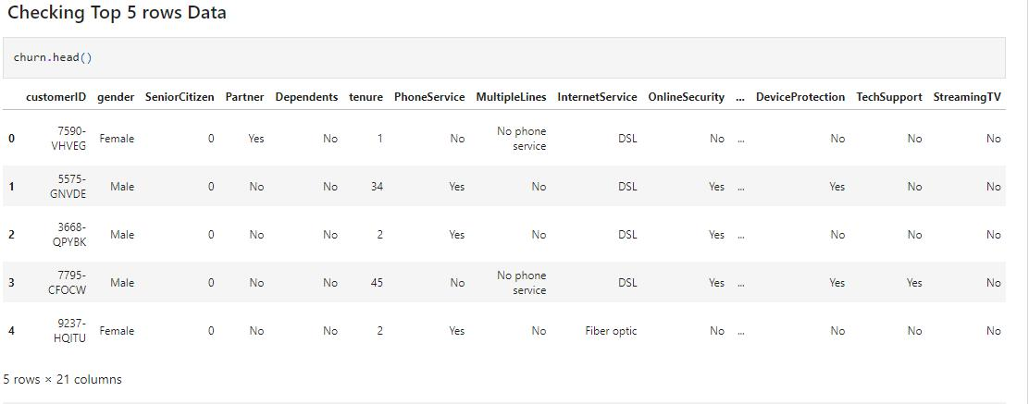**Checking Top 5 rows of Dataset to analyse the data/values of dataset**

* **Analyzing Total Numbers of Rows and Column and All Column Names**

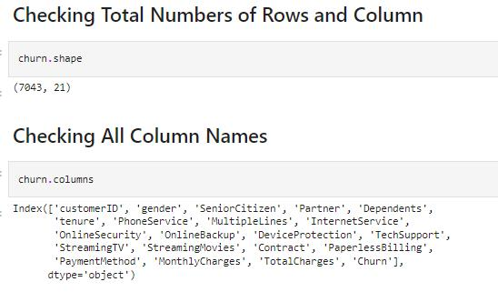

We observed that this dataset contains 7043 rows and 21 columns. Names of column with brief description are:

**Features columns:**

* **CustomerID:** Customer ID unique for each customer
* **gender:** Whether the customer is a male or a female
* **SeniorCitizen:** Whether the customer is a senior citizen or not (1, 0)
* **Partner:** Whether the customer has a partner or not (Yes, No)
* **Dependent:** Whether the customer has dependents or not (Yes, No)
* **PhoneService:** Whether the customer has a phone service or not (Yes, No)
* **MultipeLines:** Whether the customer has multiple lines or not (Yes, No, No phone service)
* **InternetService:** Customer’s internet service provider (DSL, Fiber optic,

No)

* **OnlineSecurity:** Whether the customer has online security or not (Yes, No, No internet service)
* **OnlineBackup:** Whether the customer has an online backup or not (Yes, No, No internet service)
* **DeviceProtection:** Whether the customer has device protection or not (Yes, No, No internet service)
* **TechSupport:** Whether the customer has tech support or not (Yes, No, No internet service)
* **StreamingTV:** Whether the customer has streaming TV or not (Yes, No, No internet service)
* **StreamingMovies:** Whether the customer has streaming movies or not (Yes, No, No internet service)
* **Contract:** The contract term of the customer (Month-to-month, One year, Two years)
* **PaperlessBilling:** The contract term of the customer (Month-to-month, One year, Two years)
* **PaymentMethod:** The customer’s payment method (Electronic check,

Mailed check, Bank transfer (automatic), Credit card (automatic))

* **Tenure:** Number of months the customer has stayed with the company
* **MonthlyCharges:** The amount charged to the customer monthly
* **TotalCharges:** The total amount charged to the customer

**Target column:**

* **Churn**: Whether the customer churned or not (Yes or No)

**These features can also be subdivided into:**

* **Demographic customer information:** gender, SeniorCitizen, Partner, Dependents
* **Services Information:** PhoneService, MultipleLines, InternetService, OnlineSecurity, OnlineBackup, DeviceProtection, TechSupport, StreamingTV, StreamingMovies
* **Customer account information:** tenure, Contract, PaperlessBilling, PaymentMethod, MonthlyCharges, TotalCharges
* 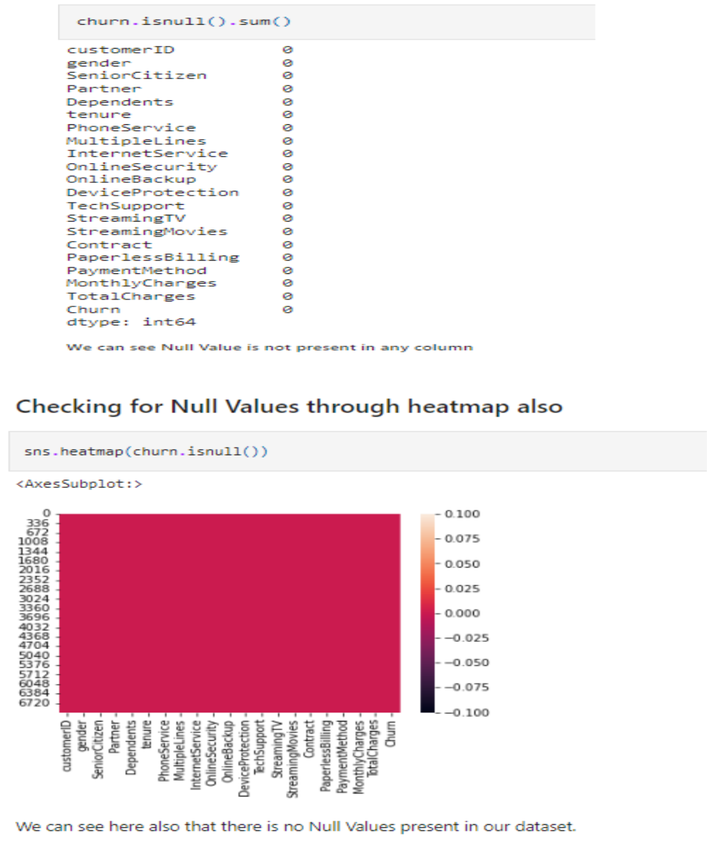**Analysing Null Values**

We can observe there are no Null Values in Dataset.

* **Let’s plot to Analyse each column’s data through Data Visualization**
* **Univariant Analysis**
  + 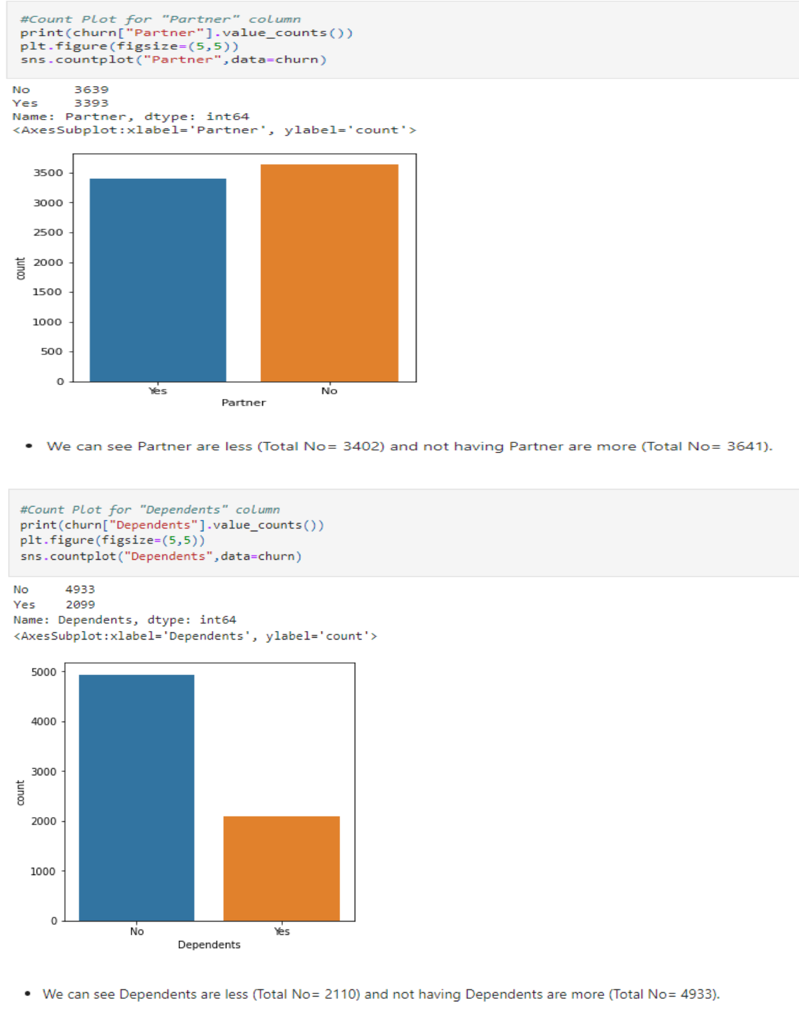Using count plot (for Categorical Columns)

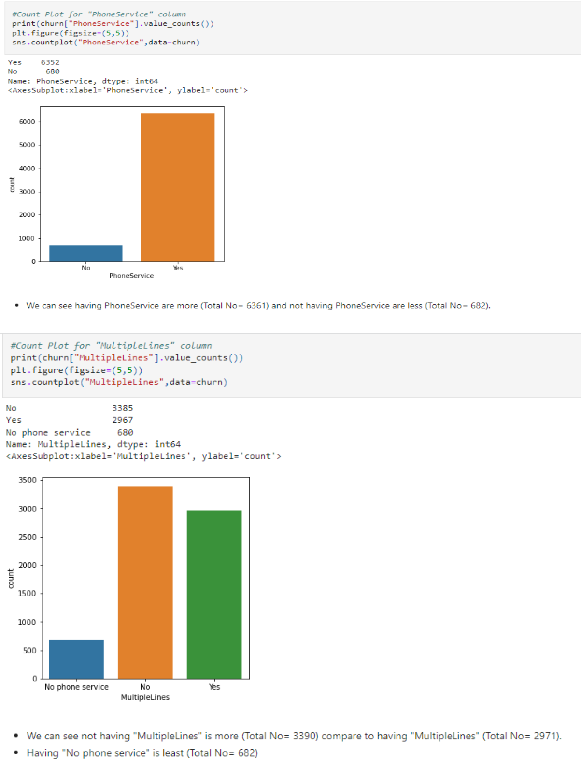

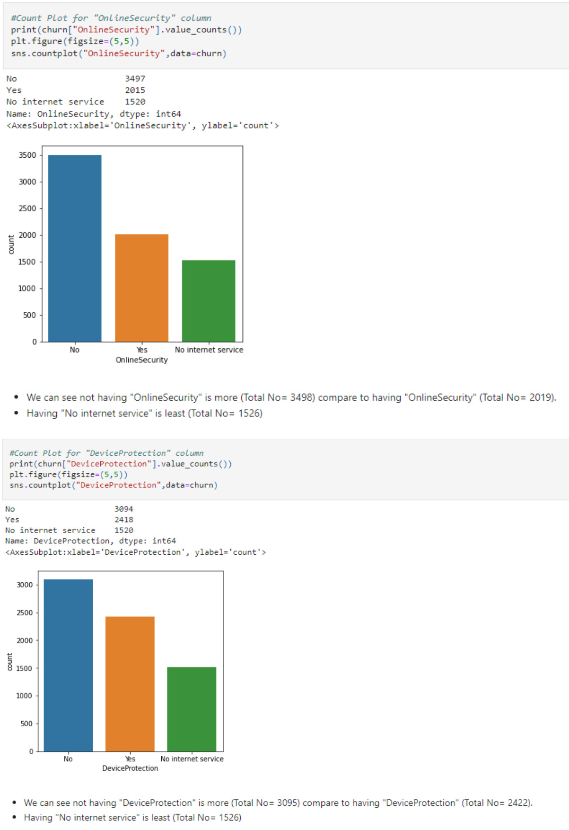

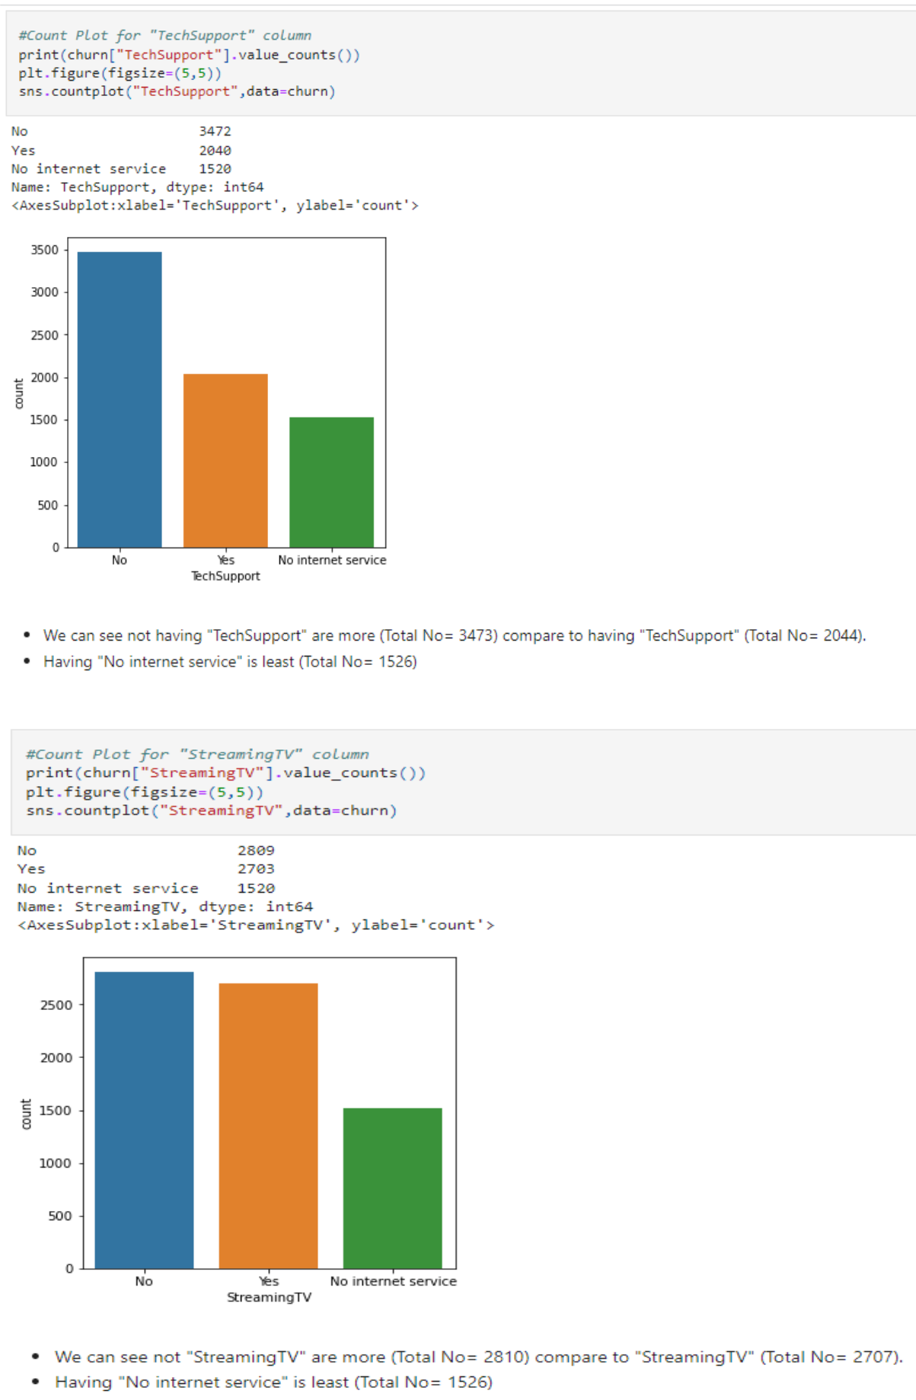

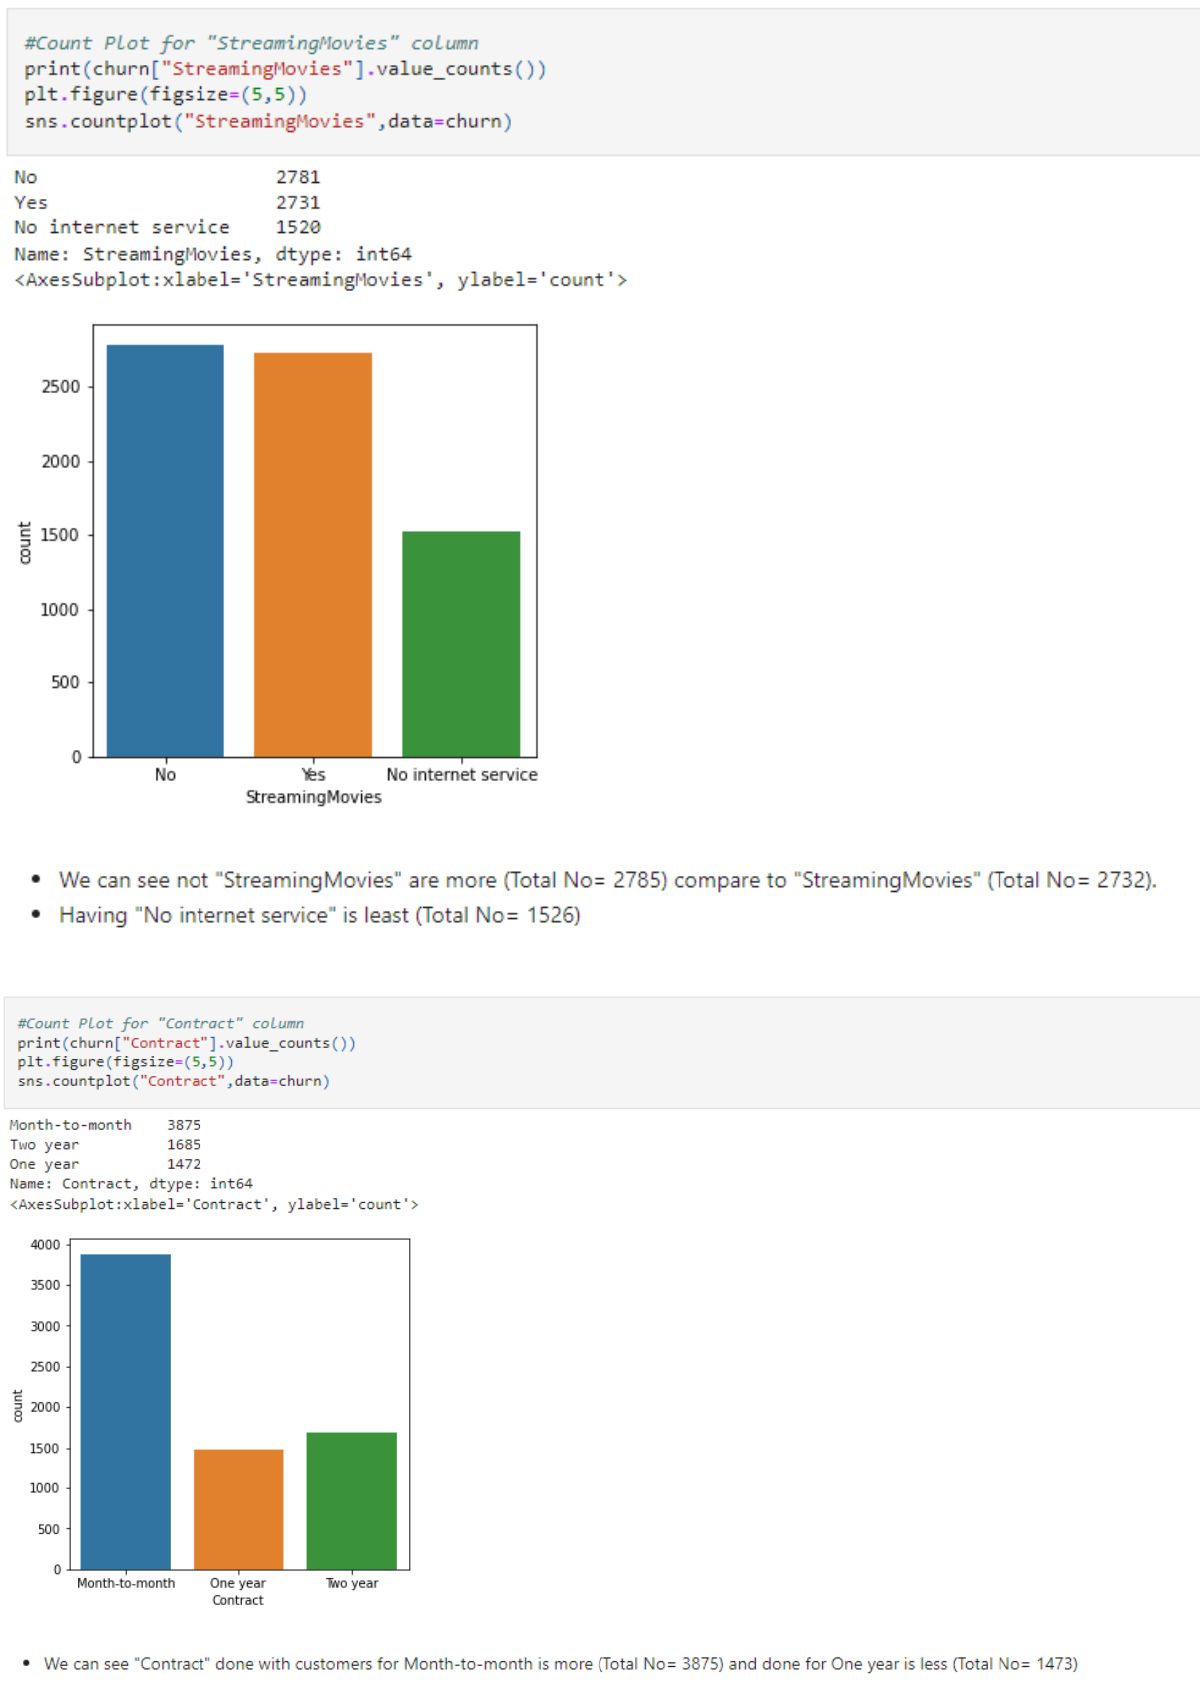

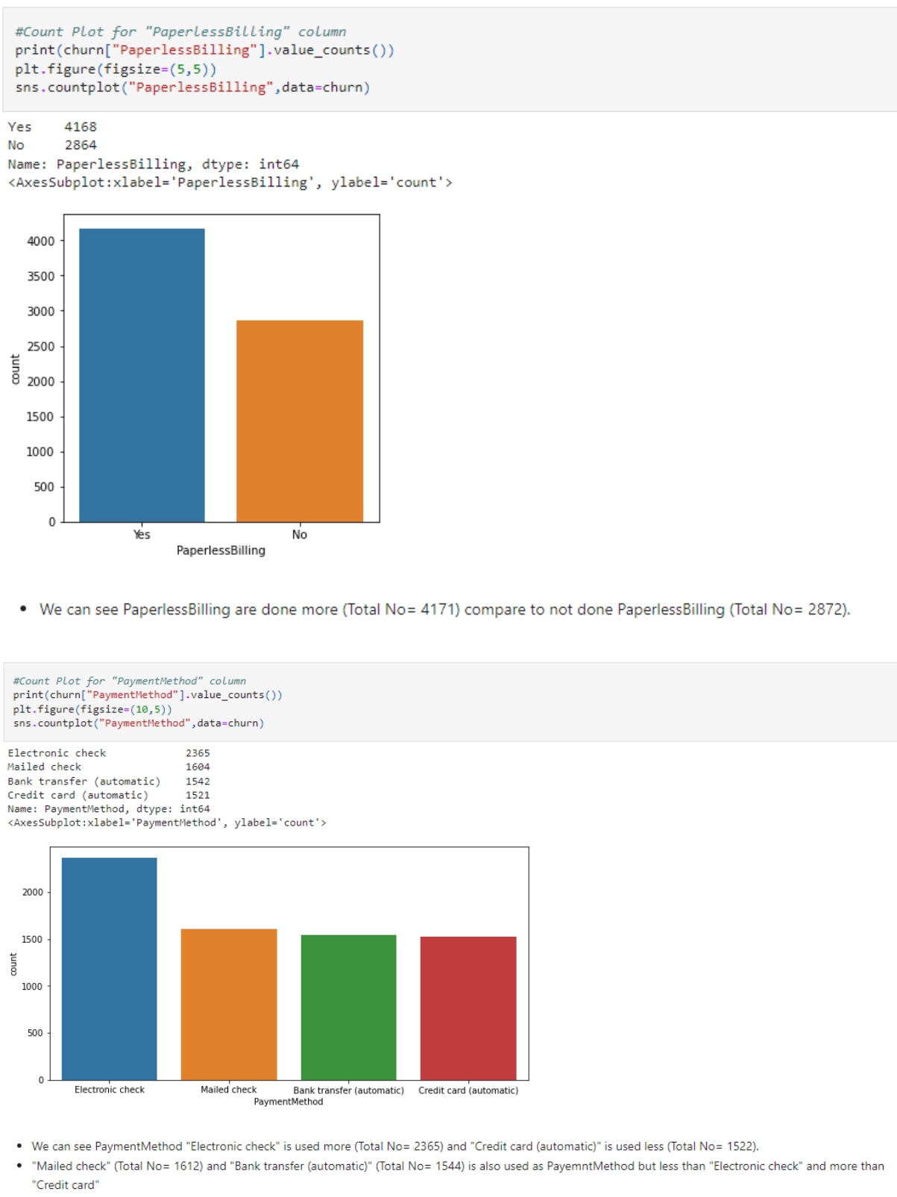

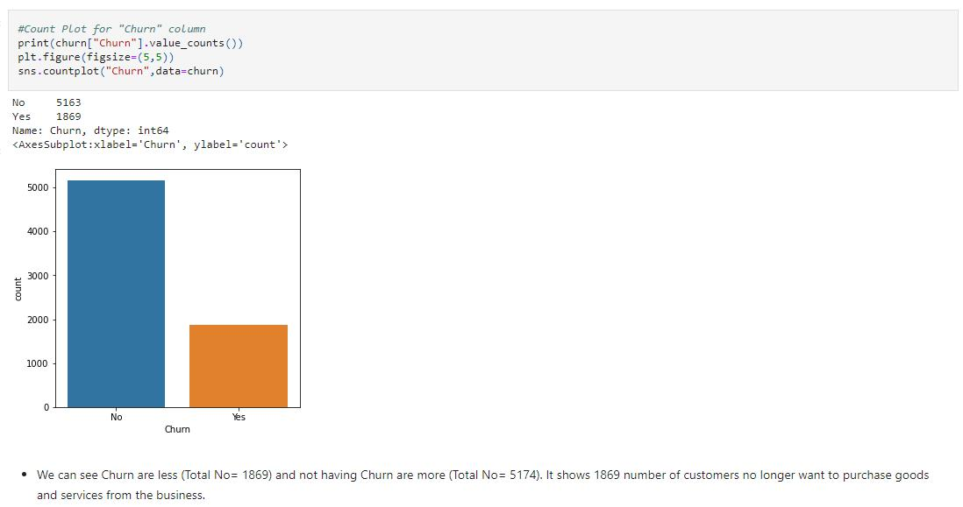

* 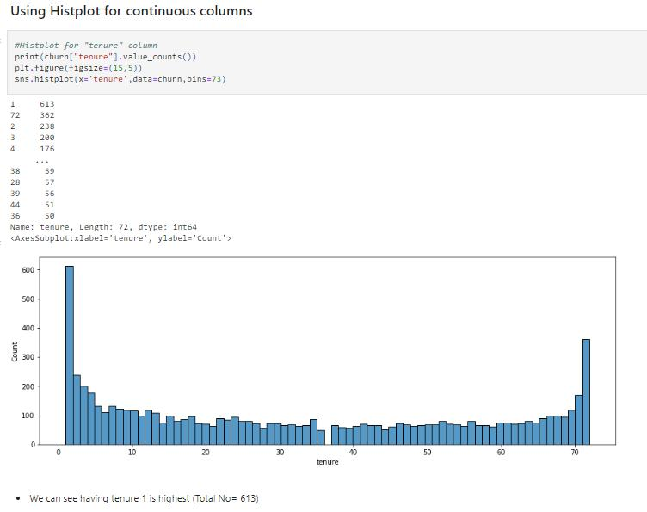Using Histplot (for Continuous Columns)

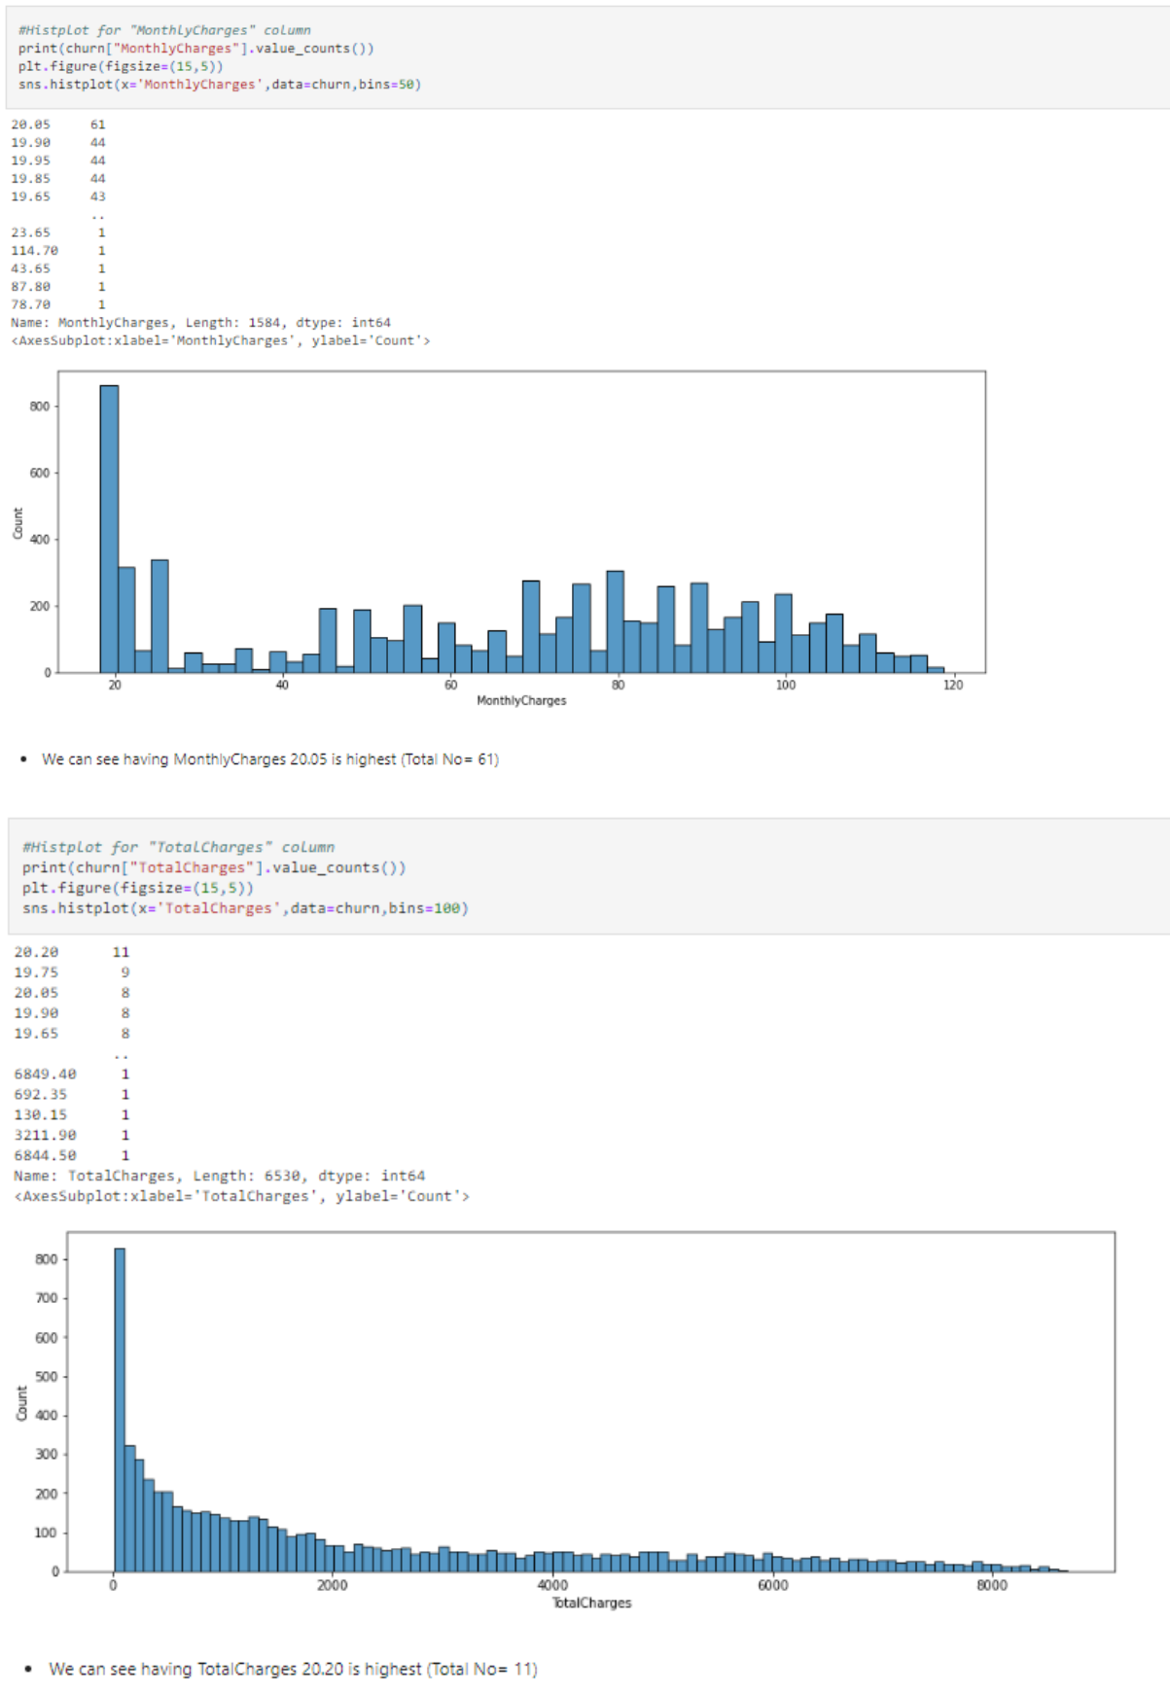

* Bivariant Analysis (for comparison)
  + Using countplot (for comparison between categorical column and target)

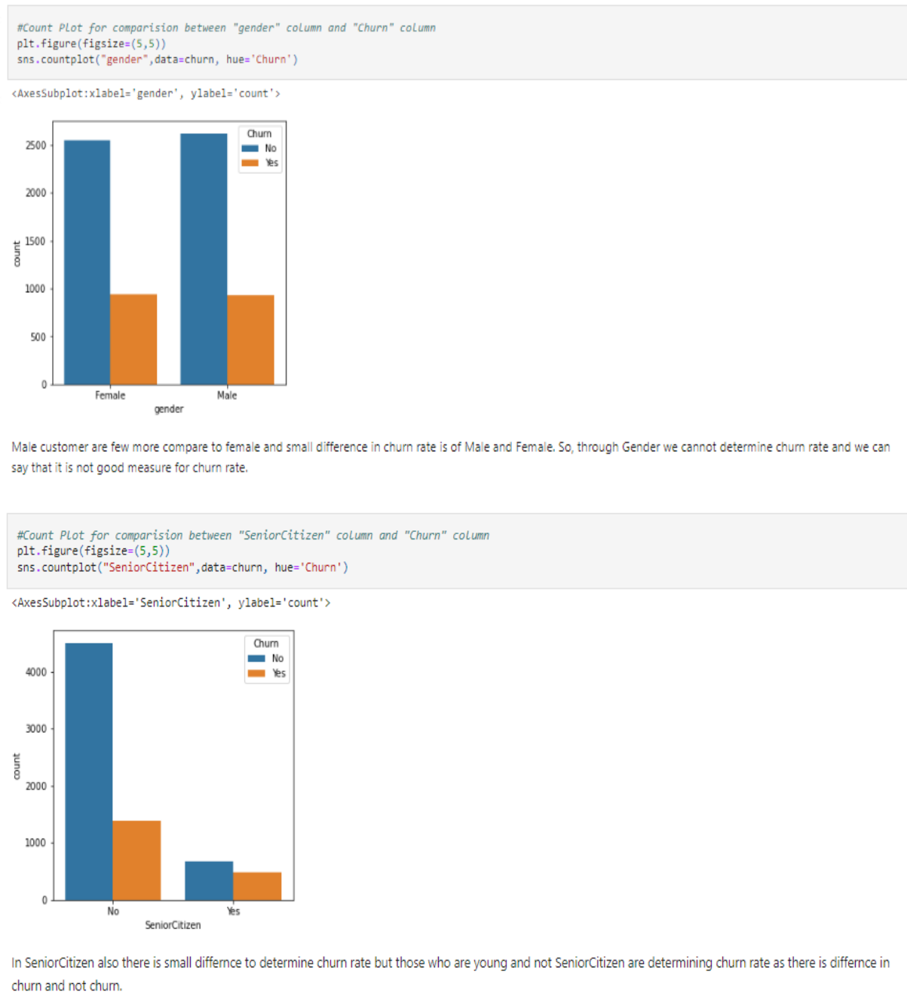

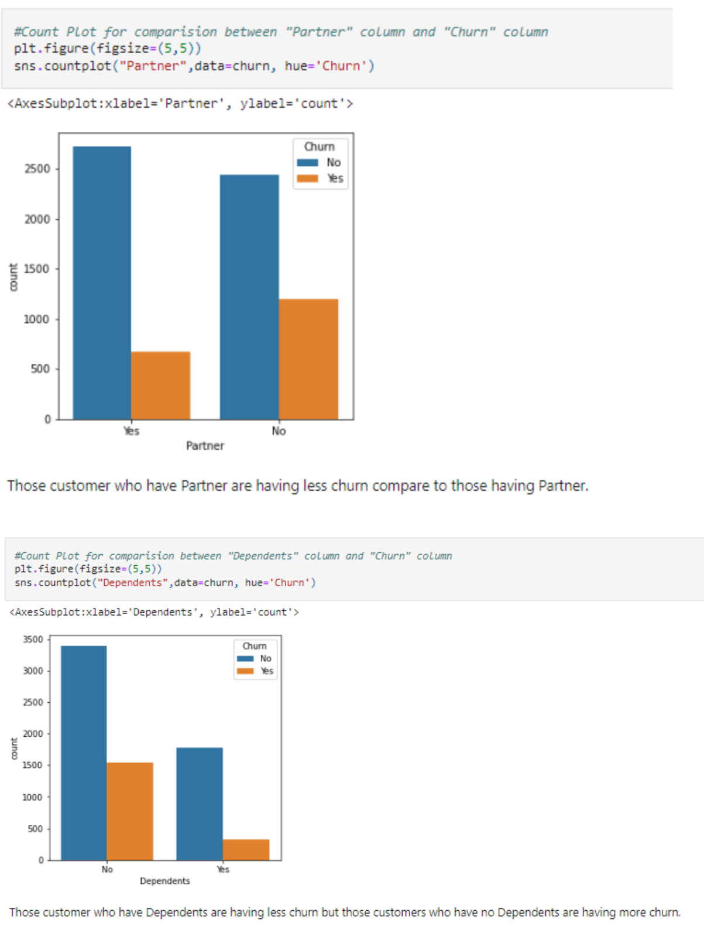

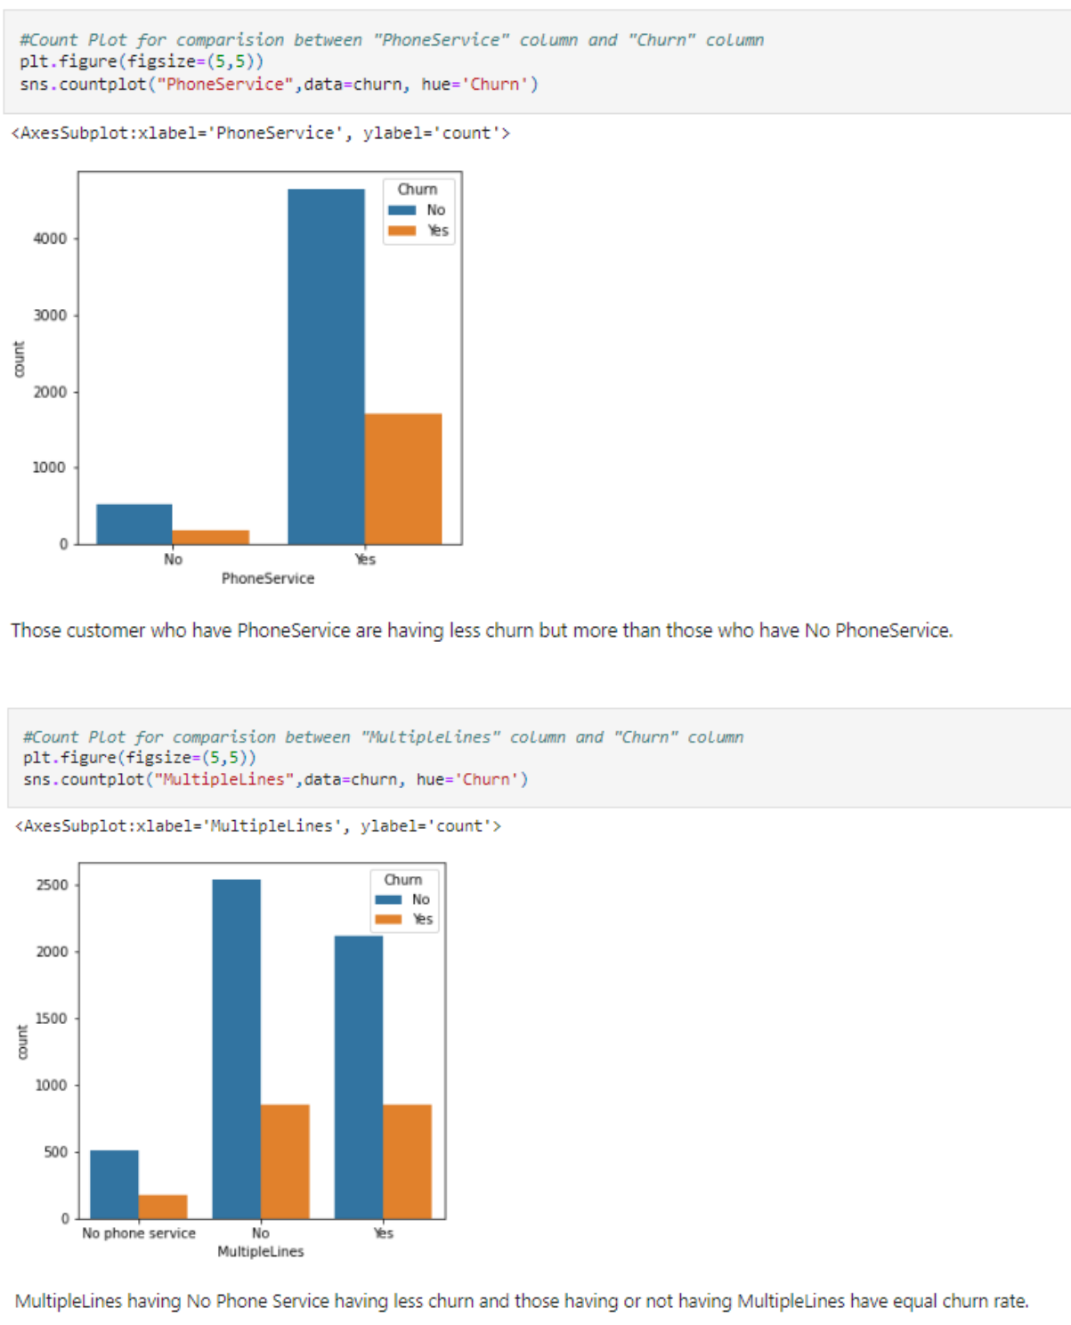

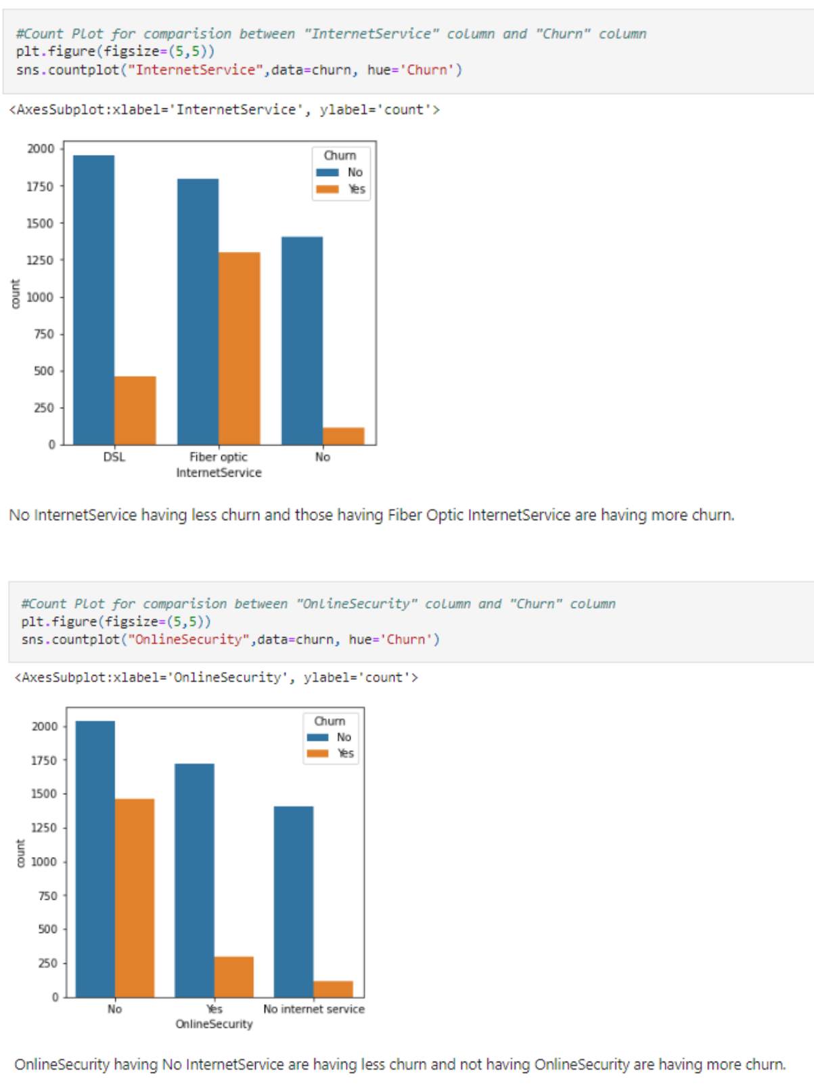

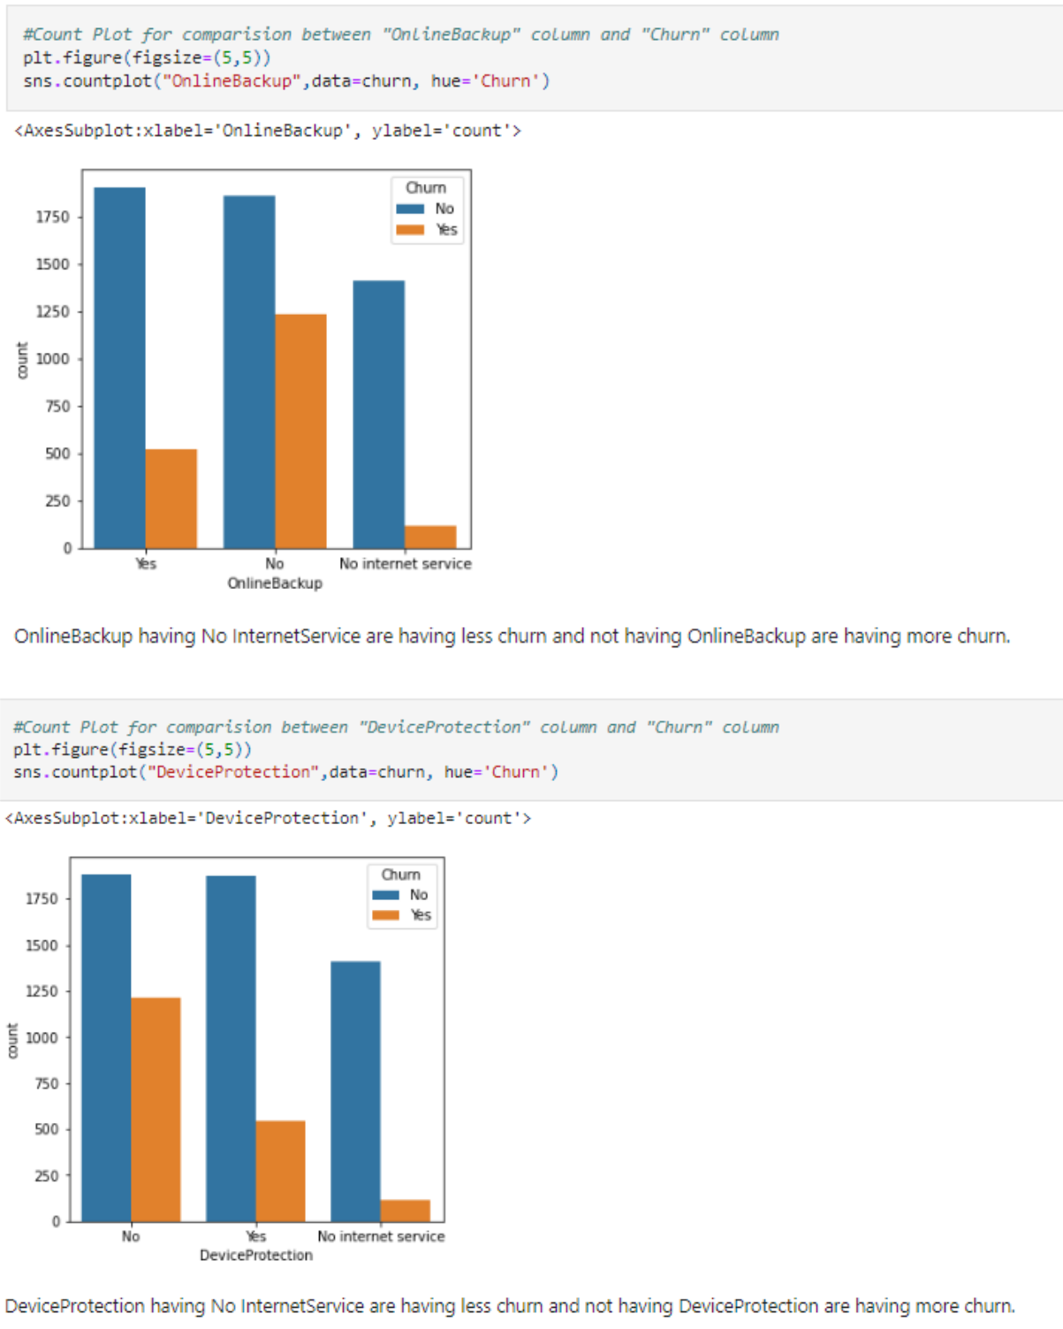

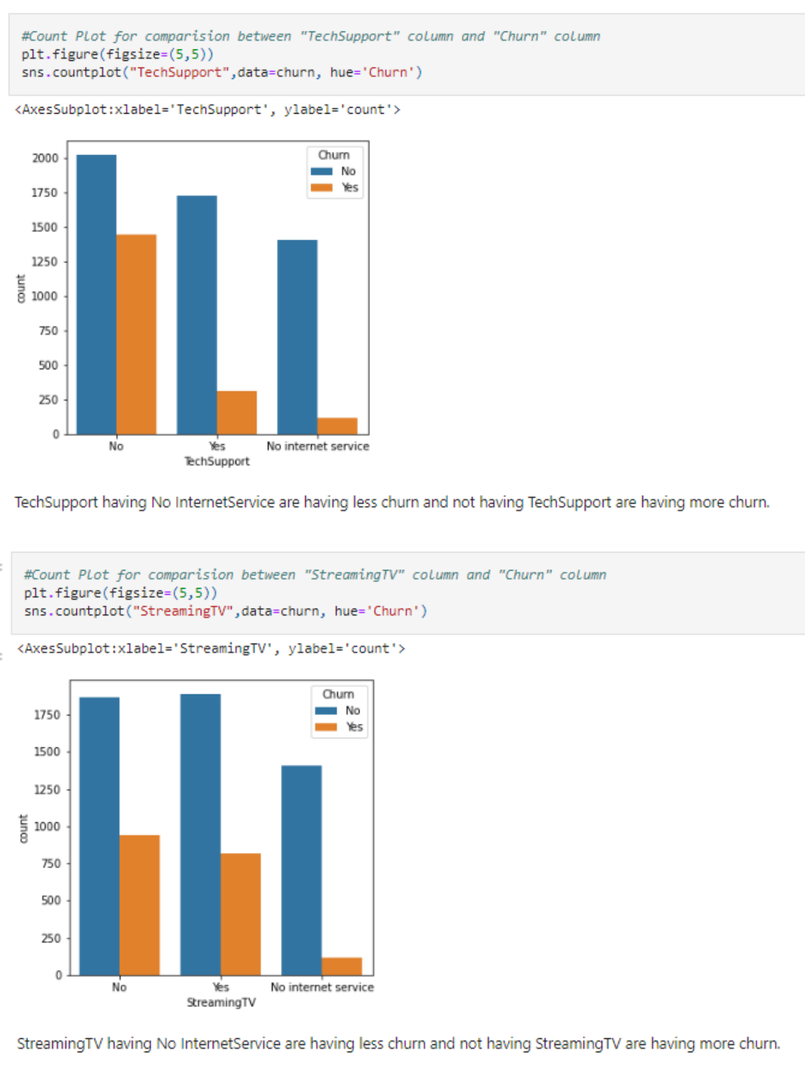

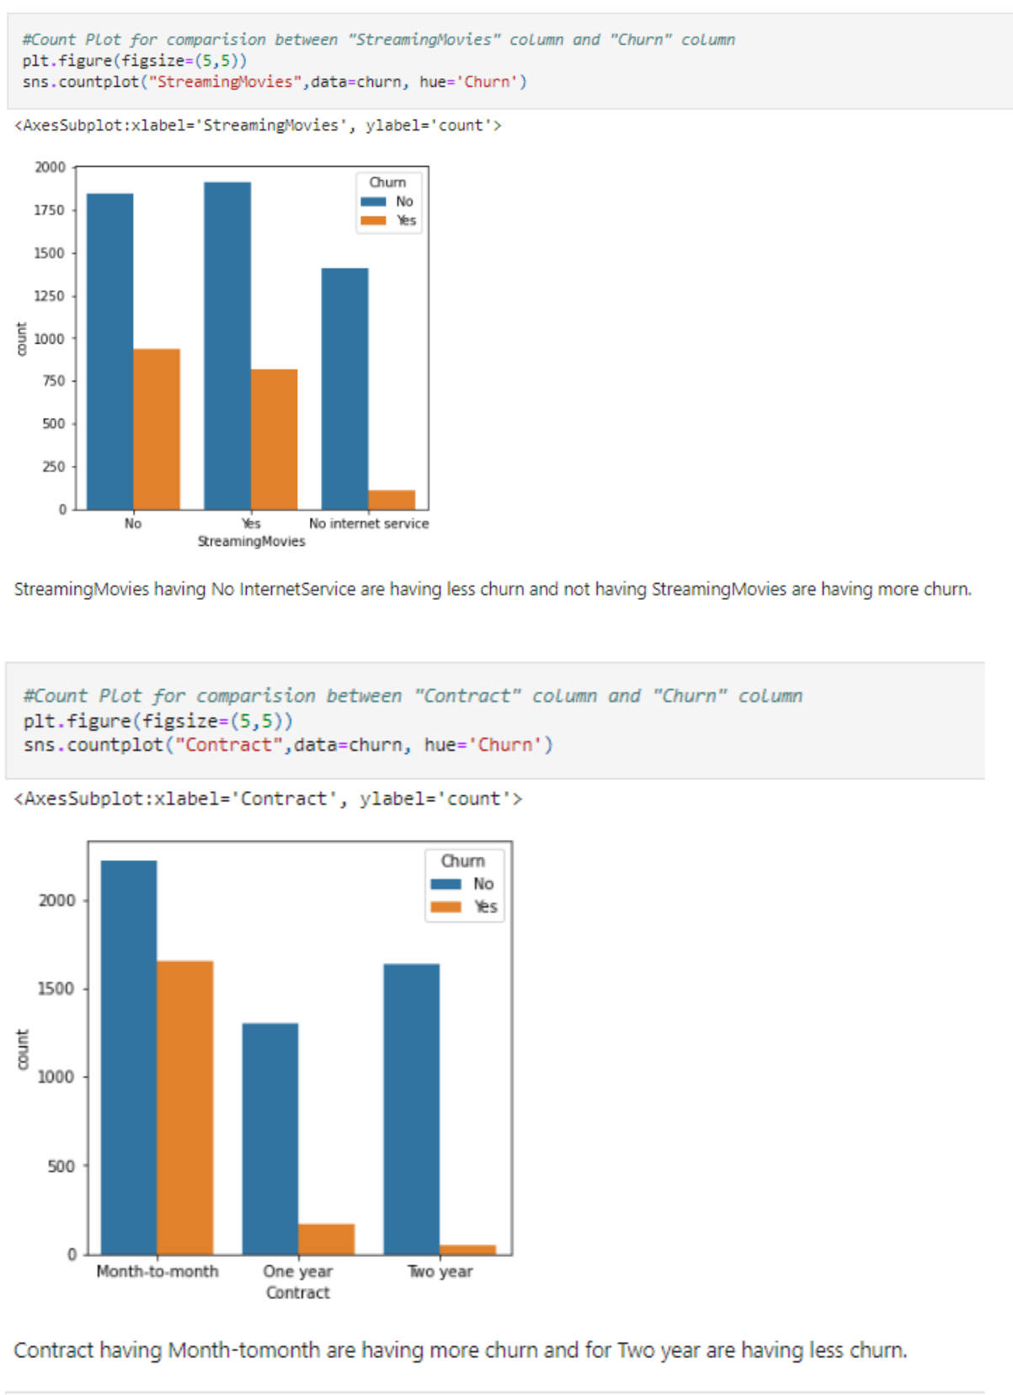

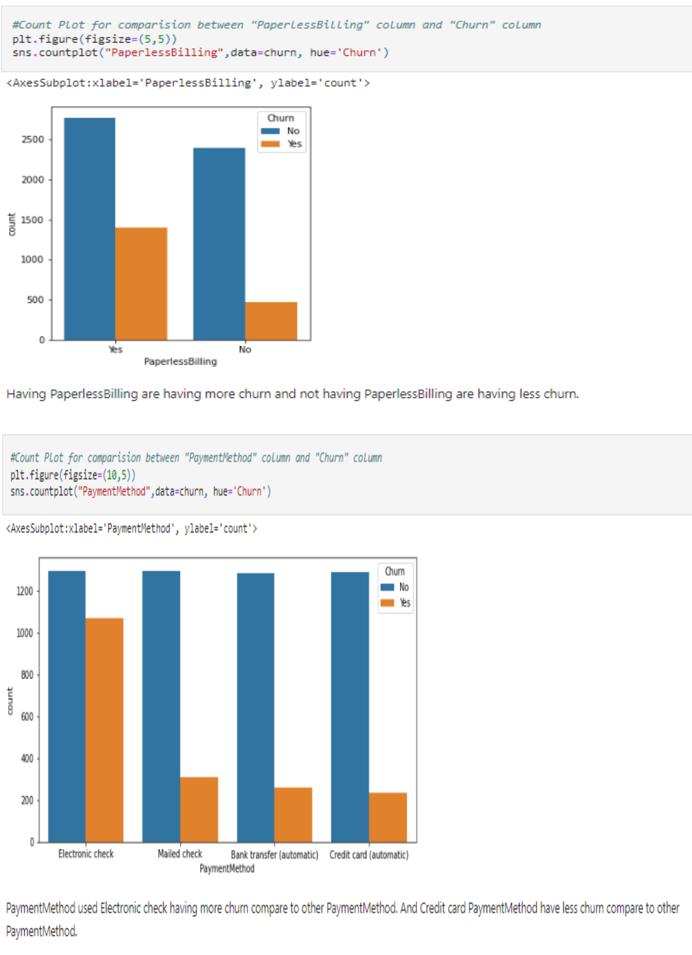

* Using Barplot (for comparison between continuous column and target)

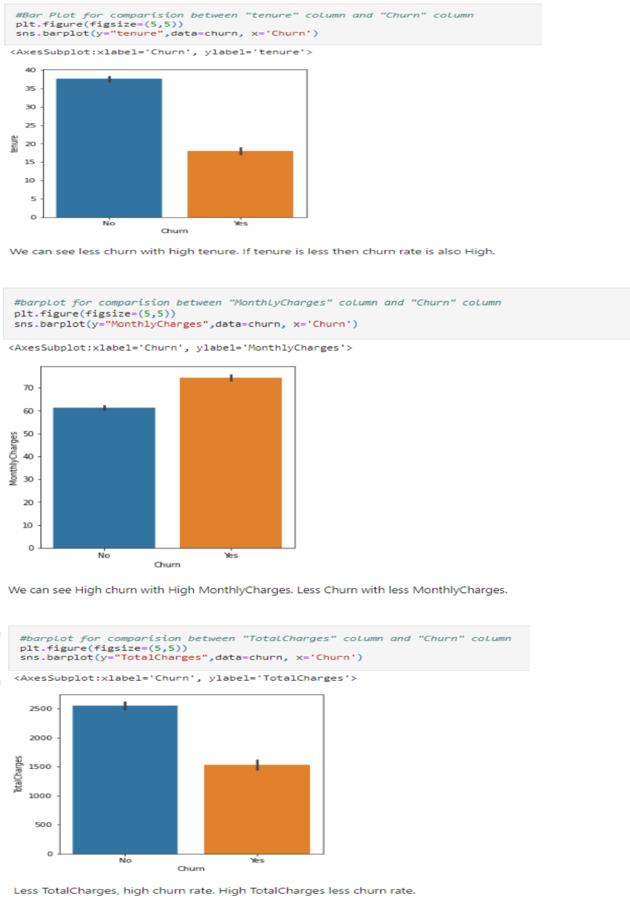

* **Multivariant Analysis:** Using Pairplot

(Relationship between continuous and target column)

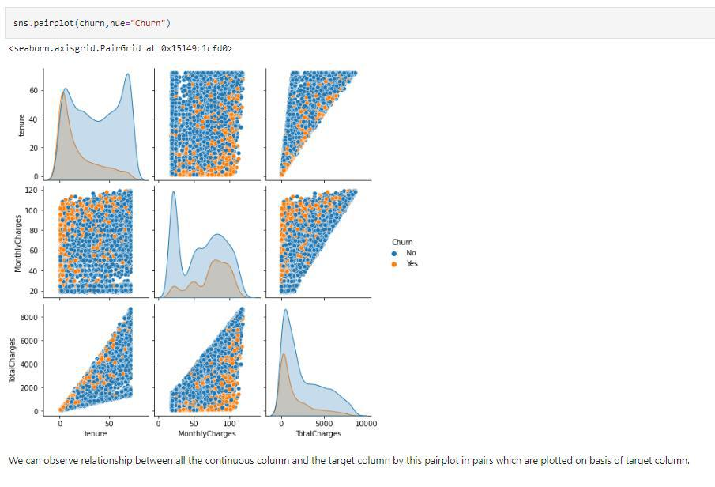

**Observation of Data Visualisation**

* The churn rate of senior citizens is approx. double of young citizens.
* We cannot determine churn rate through Gender as both male and female are equal.
* Customers with partner is having less churn compare to customers with no partner.
* Customers with month-to-month contracts have higher churn rates compared to Customers having yearly contracts.
* Customers who opted for an electronic check as paying method are having more churn rate.
* Customers subscribed to paperless billing churn more
* The churn rate is high when monthly charges are high.
* New customers churn more.
* Clients with high total charges having less churn.
* We do not expect phone attributes (PhoneService and MultipleLines) to have significant predictive power. The percentage of churn for all classes in both independent variables is nearly the same.
* Clients with online security churn less.
* Customers with no tech support tend to churn more often than those with tech support.

1. **EDA Concluding Remark**

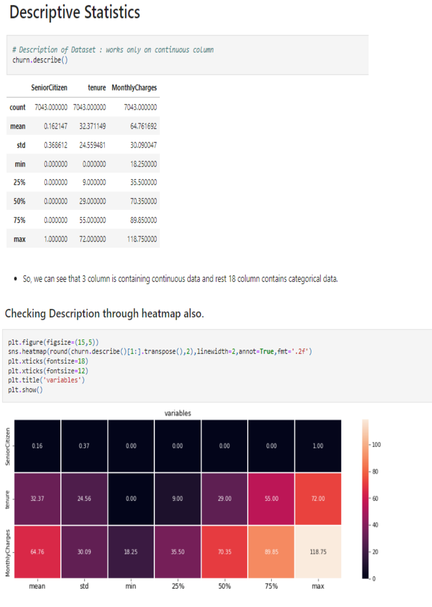

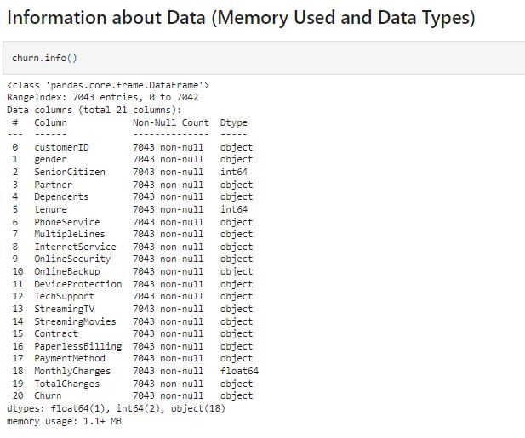

There are 18 categorical features including Target Feature and 3 continuous features in Dataset.

We also observed through visualization that column TotalCharges is wrongly detected as **object data type.** This column represents the total amount charged to the customer and it should be a numeric variable. So, for further analysis, we need to transform this column into a **numeric data type** through function pd.to_numeric.



After converting Datatype of column TotalCharges, we can see there are 11 null values present in column TotalCharges. So handled null values through mean mode.

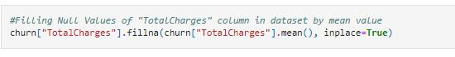

And also observed that column tenure is having 0 values. So have to handle this too. So, first check for index number where 0 values are present.



We get these index numbers:



Therefore, to handle this we are dropping these rows as it is only 11 and it will not affect prediction.

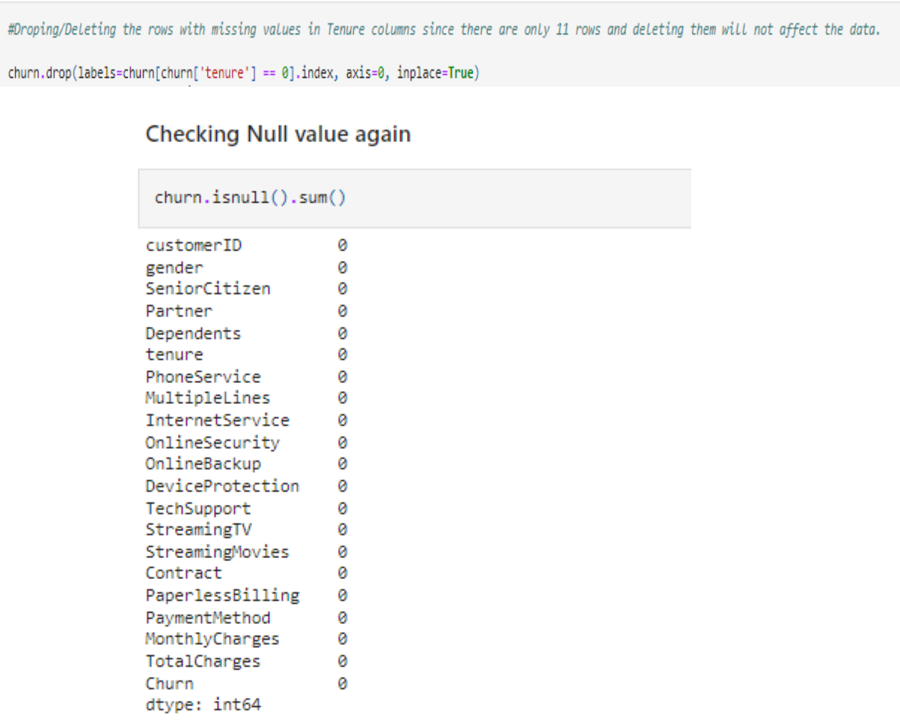

1. **Pre-Processing Pipeline**

Column customerID is having unique value for each data so it has no relation with Target. Hence, will drop this column.

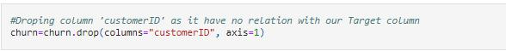

* **Label Encoding**

Label Encoding refers to converting the labels into a numeric form to convert them into the machine-readable form. Machine learning algorithms can then decide in a better way how those labels must be operated. It is an important pre-processing step for the structured dataset in supervised learning.

So, we are encoding the data by transforming from categorical to continuous.

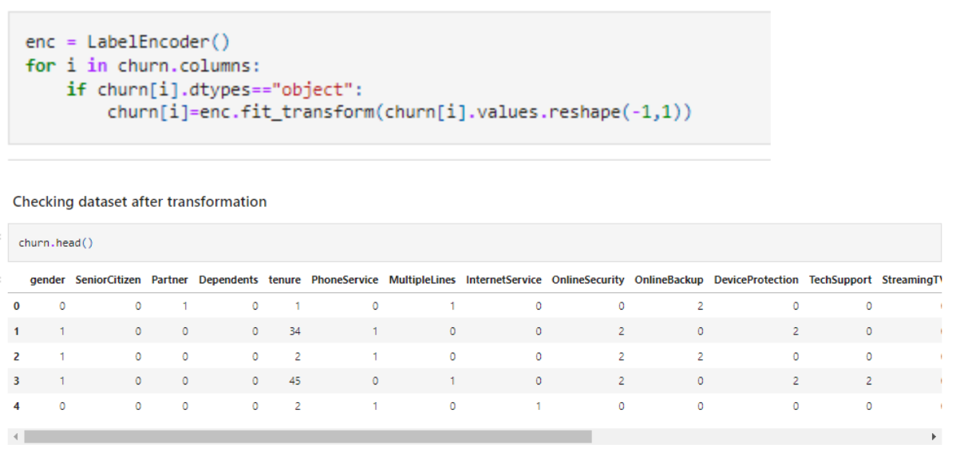

* **Checking Correlation**

Data correlation is the way in which one set of data may correspond to another set means measures the linear relationship between two variables. It describes how one or more variables are related to each other. These variables can be input data features which have been used to forecast our target variable.

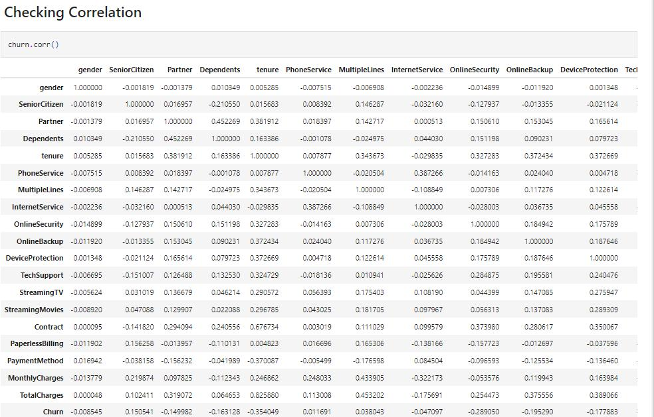

* Checking correlation in ascending order also to get highest and lowest correlated values.

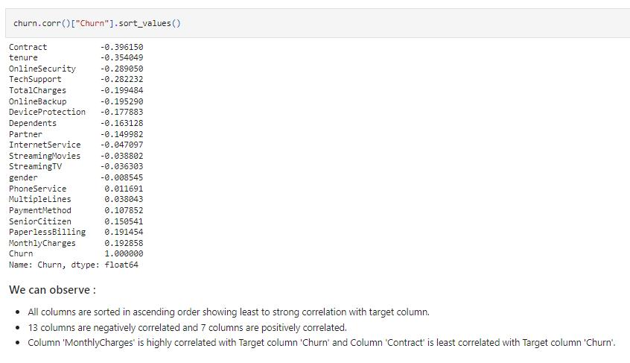

* Observing correlation through data visualization also:

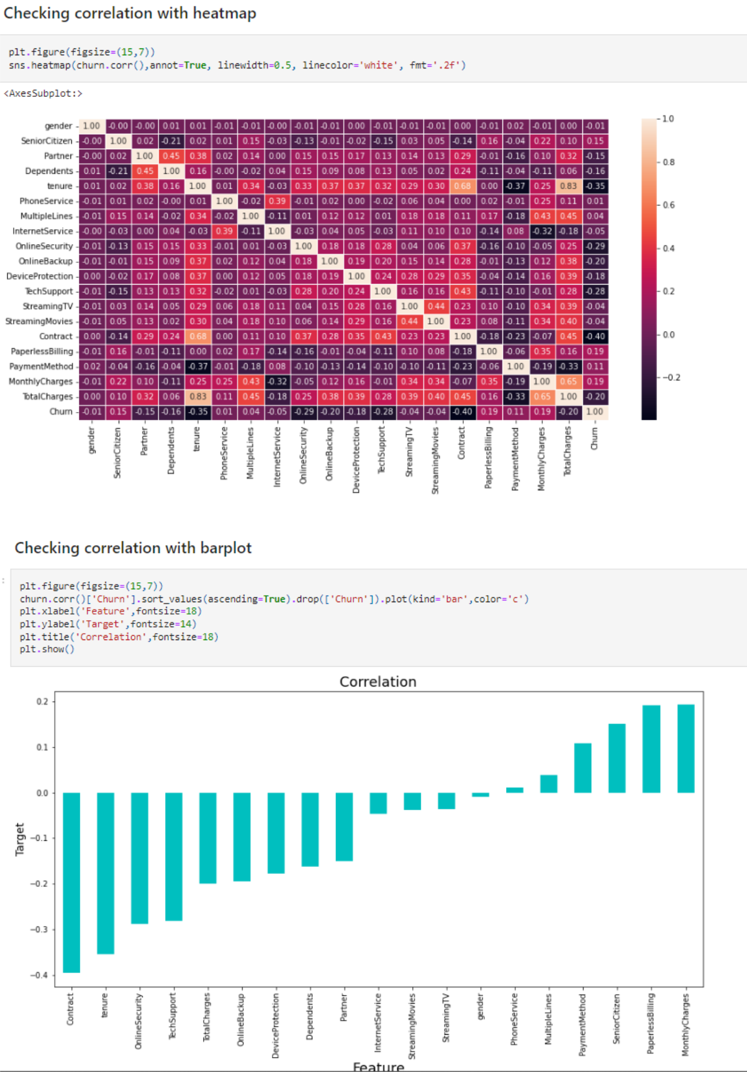

* **Observation of Correlation:**

1. gender has -1 percent correlation with the target column which can

be considered as good correlation and negatively correlated.

1. SeniorCitizen has 15 percent correlation with the target column

which can be considered as good correlation and positively correlated.

1. Partner has -15 percent correlation with the target column which

can be considered as good correlation and negatively correlated.

1. Dependents has -16 percent correlation with the target column which can be considered as good correlation and negatively

correlated.

1. tenure has -35 percent correlation with the target column which can

be considered as good correlation and negatively correlated.

1. PhoneService has 1 percent correlation with the target column which can be considered as good correlation and positively correlated.
2. MultipleLines has 4 percent correlation with the target column which can be considered as good correlation and positively correlated.
3. InternetService has -5 percent correlation with the target column which can be considered as good correlation and negatively

correlated.

1. OnlineSecurity has -29 percent correlation with the target column which can be considered as good correlation and negatively

correlated.

1. OnlineBackup has -20 percent correlation with the target column

which can be considered as good correlation and negatively correlated.

1. DeviceProtection has -18 percent correlation with the target column which can be considered as good correlation and negatively correlated.
2. TechSupport has -28 percent correlation with the target column which can be considered as good correlation and negatively

correlated.

1. StreamingTV has -4 percent correlation with the target column which can be considered as good correlation and negatively

correlated.

1. StreamingMovies has -4 percent correlation with the target column which can be considered as good correlation and negatively correlated.

1. Contract has -40 percent correlation with the target column which can be considered as weak correlation and negatively correlated.
2. PaperlessBilling has 19 percent correlation with the target column which can be considered as good correlation and positively

correlated.

1. PaymentMethod has 11 percent correlation with the target column which can be considered as good correlation and positively

correlated.

1. MonthlyCharges has 19 percent correlation with the target column which can be considered as strong correlation and positively correlated.
   1. TotalCharges has -20 percent correlation with the target column which can be considered as good correlation and negatively correlated.

* **Max correlation** is with MonthlyCharges
* **Min correlation** is with Contract
* **Finding Outliers:**

An outlier is a data point that is noticeably different from the rest. They represent errors in measurement, bad data collection, or simply show variables not considered when collecting the data.

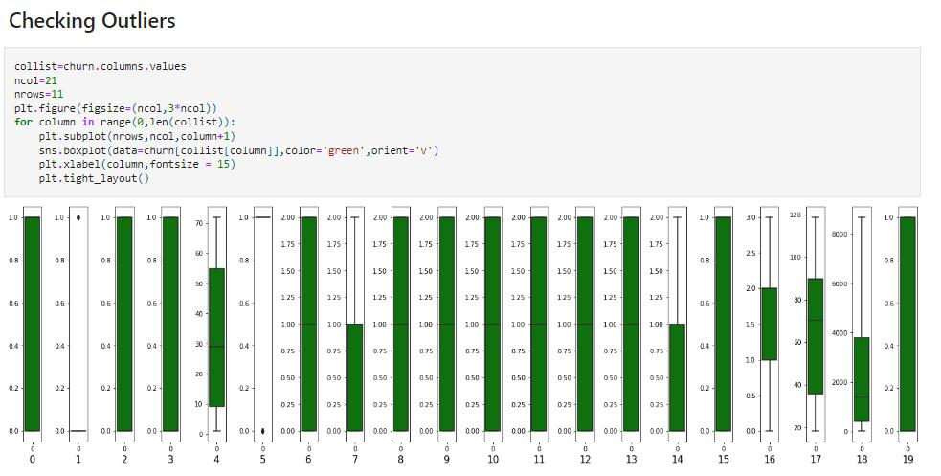

**Observation:**

We can see Outliers are present only in 2 columns: "SeniorCitizen" and "PhoneService". But both columns are categorical, so we will not remove outliers.

If Outliers were present then we have to remove through Zscore method using Scipy or IQR (Inter Quantile Range) method. Every time we should check both method for removal and then compare between both which method is giving less data loss then use that method for further process.

**Formula for Zscore method using Scipy:**

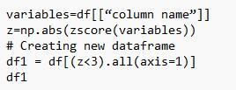

**Formula for IQR (Inter Quantile Range) method:**

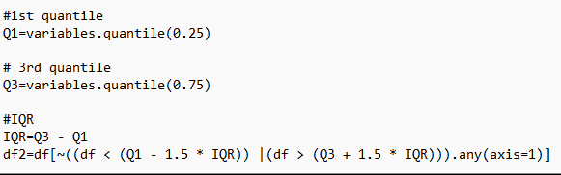

**Formula for checking Loss Percent:**

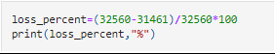

* **Finding Skewness:**

Skewness is asymmetry in a statistical distribution, in which the curve appears distorted or skewed either to the left or to the right. Skewness can be quantified to define the extent to which a distribution differs from a normal distribution.

* **The three types of skewness are:**

o Right skew (also called positive skew). A right-skewed distribution is longer on the right side of its peak than on its left.

1. Left skew (also called negative skew). A left-skewed distribution

is longer on the left side of its peak than on its right.

* 1. Zero skew.

* **Skewness checked through Data Visualization also:**

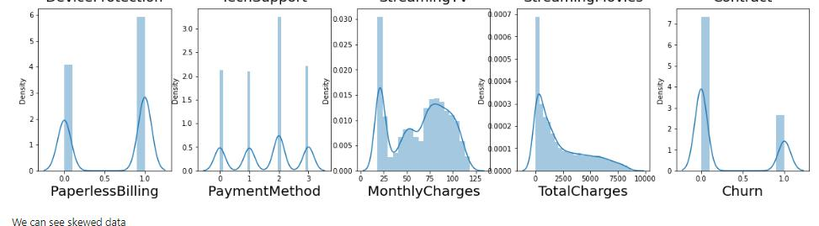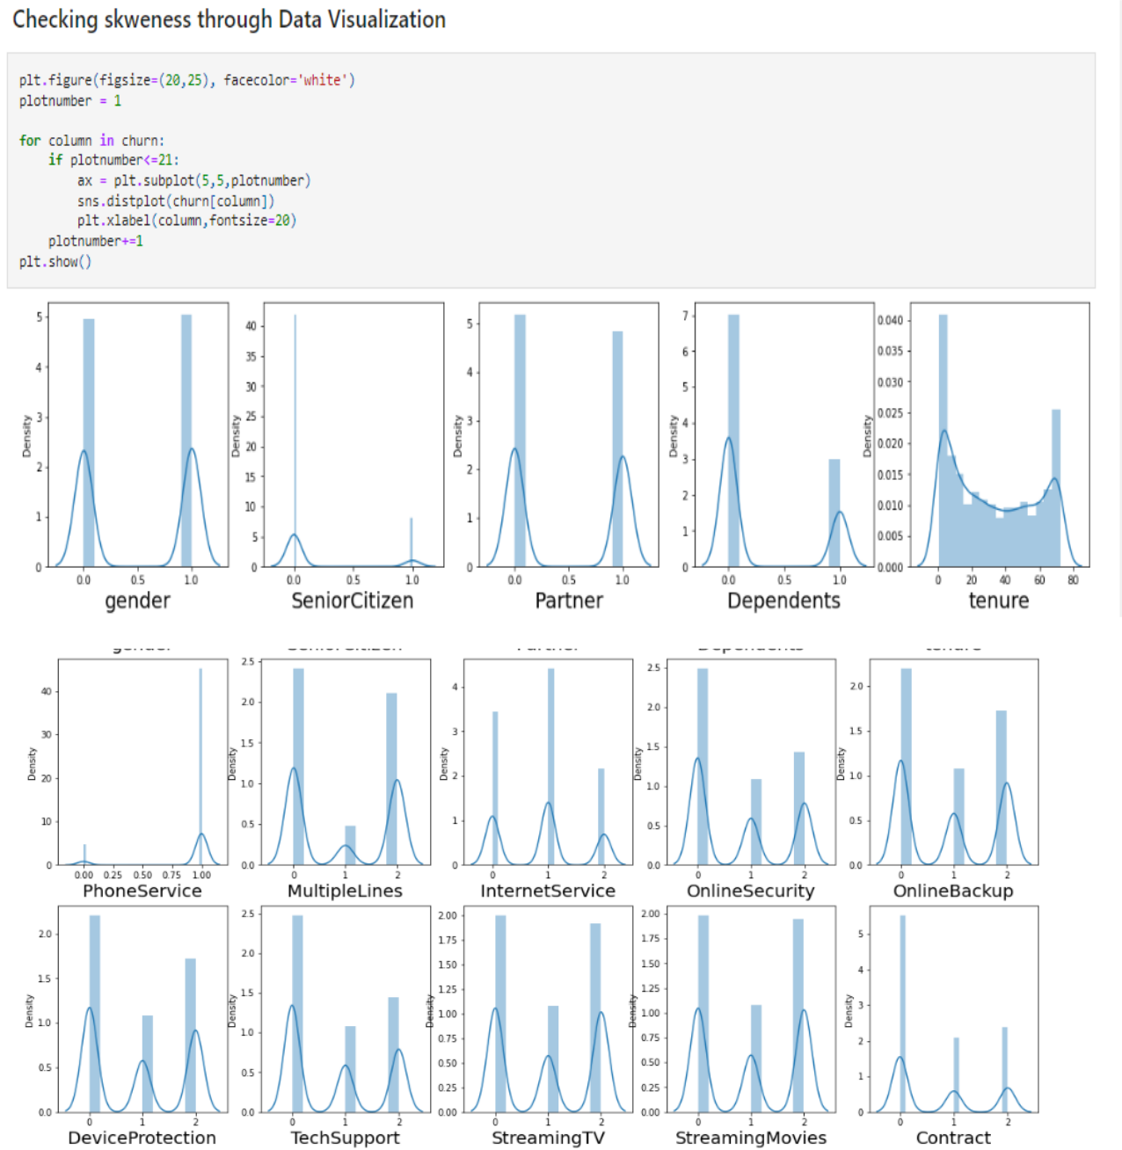

**Observation:**

* Skewness threshold taken is +/-0.25
* Columns which are having skewness: SeniorCitizen, Dependents, PhoneService, OnlineSecurity, TechSupport, Contract, PaperlessBilling and TotalCharges.
* **Removal of Skewness**

For removing skewness Power Transformer method is used. Power transforms are a technique for transforming numerical input or output variables to have a uniform or a Gaussian probability distribution. A power transform will make the probability distribution of a variable more Gaussian.

Currently, Power Transformer supports the Box-Cox transform and the Yeo-Johnson transform. The optimal parameter for stabilizing variance and minimizing skewness is estimated through maximum likelihood.

Box-Cox requires input data to be strictly positive, while Yeo-Johnson supports both positive and negative data.

So we are using Yeo-Johnson method for removing skewness. Since SeniorCitizen, Dependents, PhoneService, OnlineSecurity, TechSupport, Contract and PaperlessBilling are categorical column so we will not remove skewness from them. Only we will remove skewness from TotalCharges as this column contains continuous data.

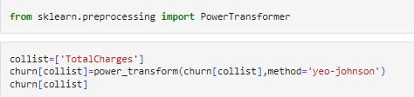

Comparison between skewed and after removal of skewness

Data before skewness removal

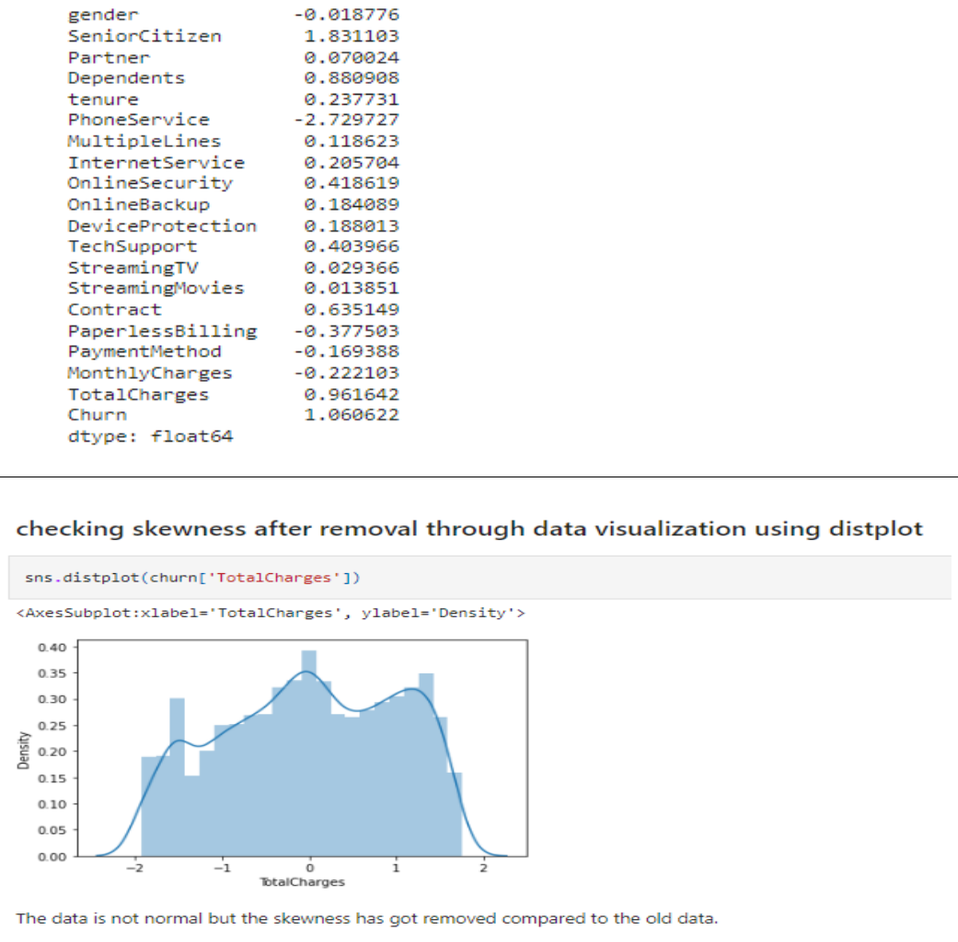

Data after skewness removal

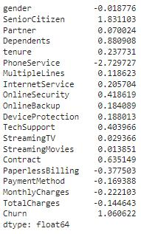

* **Splitting data into Target and Features**

Split the data set into two set: a training set and a testing set. This consists of random sampling without replacement about 75 percent of the rows and putting them into our training set and the remaining 25 percent is put into our test set.

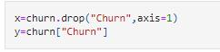Separating data into training and testing sets is an important part of evaluating data mining models. Typically, when we separate a data set into a training set and testing set, most of the data is used for training, and a smaller portion of the data is used for testing.

* Data after splitting:

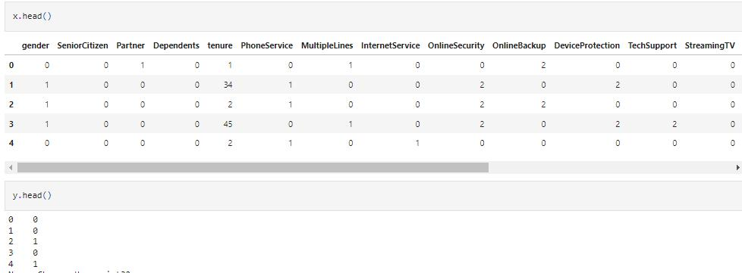

* Total value count of y column:

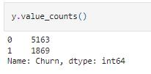

Here it is observed that data is not balanced. So, we will use oversampling method to balance it.

* **Oversampling Method**

Oversampling methods duplicate examples in the minority class or synthesize new examples from the examples in the minority class. Some of the more widely used and implemented oversampling methods include:

* Random Oversampling
* Synthetic Minority Oversampling Technique (SMOTE)
* Borderline-SMOTE
* Borderline Oversampling with SVM
* Adaptive Synthetic Sampling (ADASYN)

**Random Oversampling:**

The simplest oversampling method involves randomly duplicating examples from the minority class in the training dataset

**SMOTE:**

The most popular and most successful oversampling method is SMOTE; that is an acronym for Synthetic Minority Oversampling Technique.

SMOTE works by selecting examples that are close in the feature space, drawing a line between the examples in the feature space and drawing a new sample as a point along that line.

So, to balance the data here using SMOTE method

**Borderline-SMOTE:**

Selecting those instances of the minority class that are misclassified, such as with a k-nearest neighbor classification model, and only generating synthetic samples that are “difficult” to classify is Borderline-SMOTE.

**Borderline Oversampling with SVM:**

It is an extension to SMOTE that fits an SVM to the dataset and uses the decision boundary as defined by the support vectors as the basis for generating synthetic examples, again based on the idea that the decision boundary is the area where more minority examples are required.

**Adaptive Synthetic Sampling (ADASYN):**

(ADASYN) is another extension to SMOTE that generates synthetic samples inversely proportional to the density of the examples in the minority class. It is designed to create synthetic examples in regions of the feature space where the density of minority examples is low, and fewer or none where the density is high.

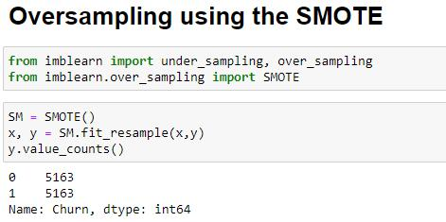

* **Scaling Data:**

It is a step of Data Pre-Processing that is applied to independent variables or features of data. It basically helps to normalize the data within a particular range. Sometimes, it also helps in speeding up the calculations in an algorithm.

Normalization and Standardization are the two main methods for the scaling of the data which are widely used in the algorithms where scaling is required. Both of them can be implemented by the scikit-learn libraries pre-process package.

**Normalization** is used when we want to bound our values between two numbers, typically, between [0,1] or [-1,1]. It is also known as Min-Max scaling.

**Formula for normalization:**

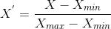

While **Standardization** transforms the data to have zero mean and a variance of 1, they make our data unitless. The values are centred around the mean with a unit standard deviation. This means that the mean of the attribute becomes zero and the resultant distribution has a unit standard deviation.

**Formula for normalization:**

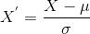

Here we are using Standardization to scale the data.

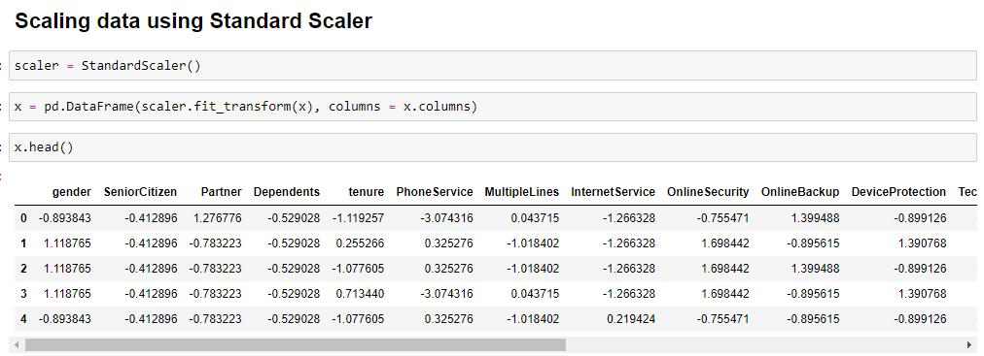

Before model creation, we need to know which features are important for prediction and which are not, So we will check using Variance Threshold Method, SelectKBest method and Multicollinearity using Variance Inflation Factor.

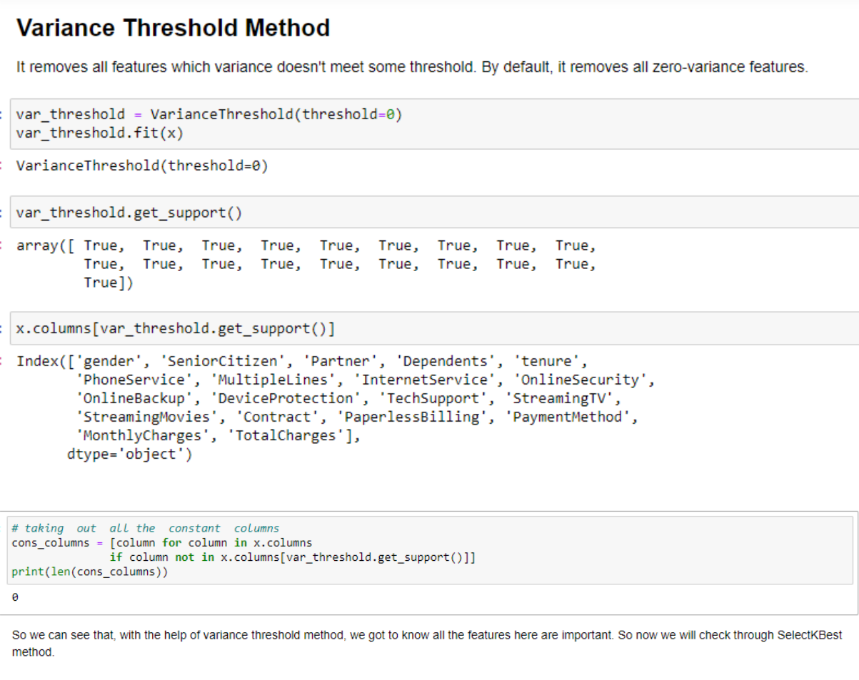

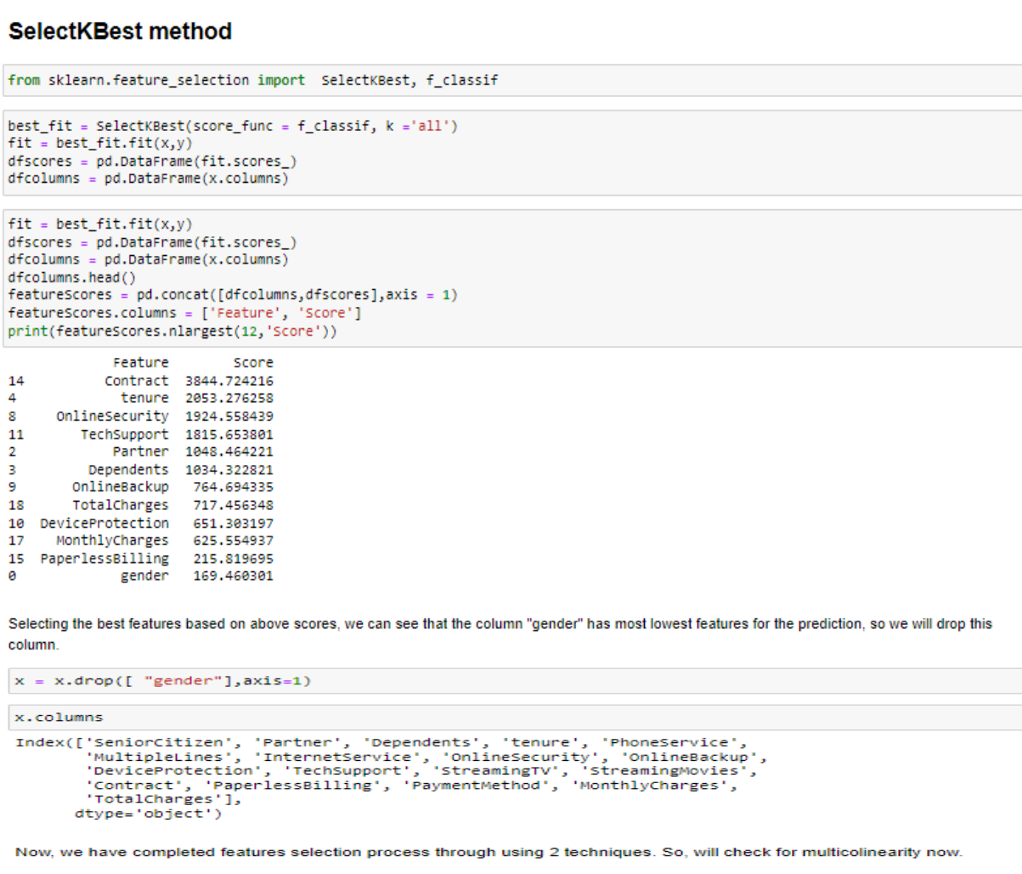

* **Checking for Multicollinearity using Variance Inflation Factor**
  + **VIF (Variance Inflation factor)**

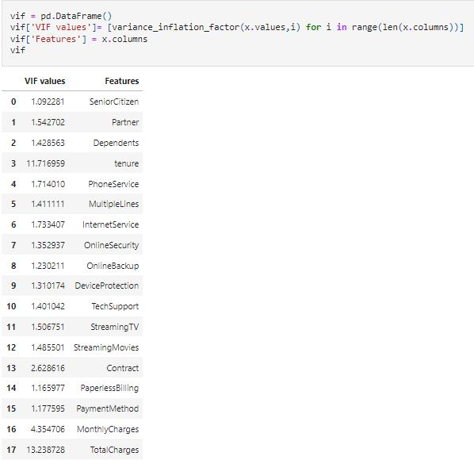

We observe that the VIF value is more than 10 in the columns 'tenure' and 'TotalCharges'. But column 'TotalCharges' is having highest VIF value. So, we will drop column 'TotalCharges' and after dropping we will again check multicollinearity.

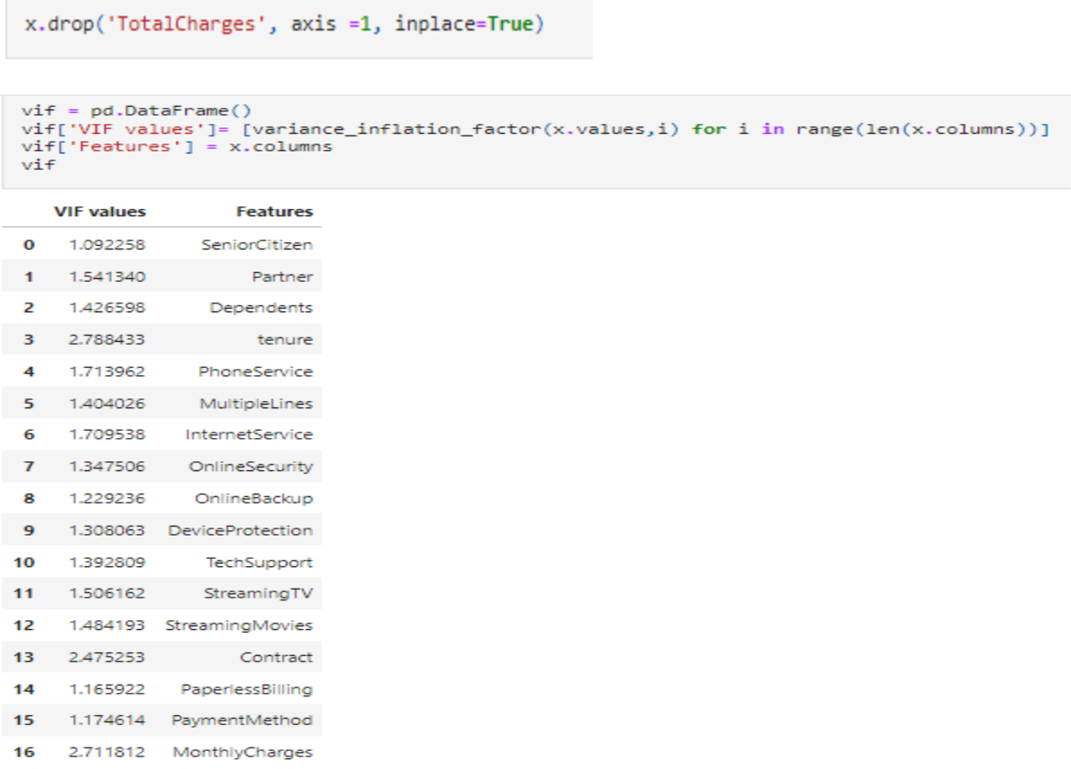

Now, we can check Multicollinearity is removed from the columns as VIF value of all columns are less than 10. So, we will create model now.

1. **Building Machine Learning Models**

Classification Model will be built for Target Variable “Churn” as it contains categorical data. We are going to use models:

* Logistic Regression
* Random Forest Classifier
* Decision Tree Classifier
* Support Vector Machine Classifier
* KNeighbors Classifier
* Gradient Boosting Classifier
* XGB Classifier
* **Logistic Regression:**

It is a classification algorithm, that is used where the target variable is categorical. Logistic Regression is used to find a relationship between features and probability of particular outcome.

* **Random Forest Classifier:**

Random forest is basically the combination of multiple individual decision trees to act as an ensemble. Ensemble learning can be defined as a paradigm whereby multiple learners are trained to solve the same problem. Ensemble learning actually has been used in several applications such as optical character recognition, medical purpose, etc. In fact, ensemble learning can be used wherever machine learning techniques can be used.

When it comes to classification using Random Forests, the idea is that the combination of outputs of mutually exclusive nodes will outperform any individual models which are then said the predicted output. Combining multiple trees (learner) may be a better choice if the learners are performing well.

* **Decision Tree Classifier:**

Decision Tree is a Supervised learning technique that can be used for both classification and Regression problems, but mostly it is preferred for solving Classification problems. It is a tree-structured classifier, where internal nodes represent the features of a dataset, branches represent the decision rules and each leaf node represents the outcome.

In a Decision tree, there are two nodes, which are the Decision Node and Leaf Node. Decision nodes are used to make any decision and have multiple branches, whereas Leaf nodes are the output of those decisions and do not contain any further branches.

The decisions or the test are performed on the basis of features of the given dataset.

* **Support Vector Machine:**

SVM is a supervised Machine Learning algorithm that is used in many classifications and regression problems. It still presents as one of the most used robust prediction methods that can be applied to many use cases involving classifications.

It works by finding an optimal separation line called a hyperplane to accurately separate 2 or more different classes. The goal is to find the optimal hyperplane separation through training the linearly separable data with the SVM algorithm.

* **KNeighbors Classifier:**

The k-nearest neighbors algorithm, also known as KNN or k-NN, is a non-parametric, supervised learning classifier, which uses proximity to make classifications or predictions about the grouping of an individual data point.The K in the name of this classifier represents the k nearest neighbors, where k is an integer value specified by the user. Hence as the name suggests, this classifier implements learning based on the k nearest neighbors. The choice of the value of k is dependent on data.

* **Gradient Boosting Classifier**

Gradient boosting classifiers are a group of machine learning algorithms that combine many weak learning models together to create a strong predictive model. Decision trees are usually used when doing gradient boosting. Gradient boosting models are becoming popular because of their effectiveness at classifying complex datasets.

**XG Boost Classifier:**

eXtreme Gradient Boosting (XGBoost) is a scalable and improved version of the gradient boosting algorithm (terminology alert) designed for efficacy, computational speed and model performance. It is an open-source library and a part of the Distributed Machine Learning Community. XGBoost is a perfect blend of software and hardware capabilities designed to enhance existing boosting techniques with accuracy in the shortest amount of time.

**Finding the best random state among all the models**

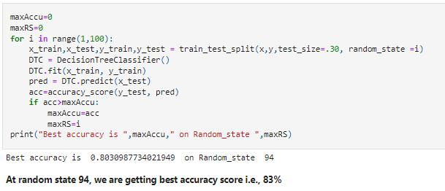

**Creating new train test split using the random state**

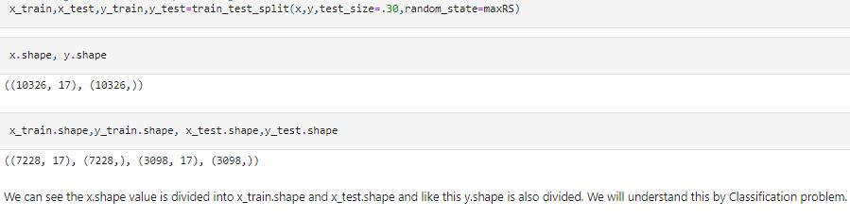

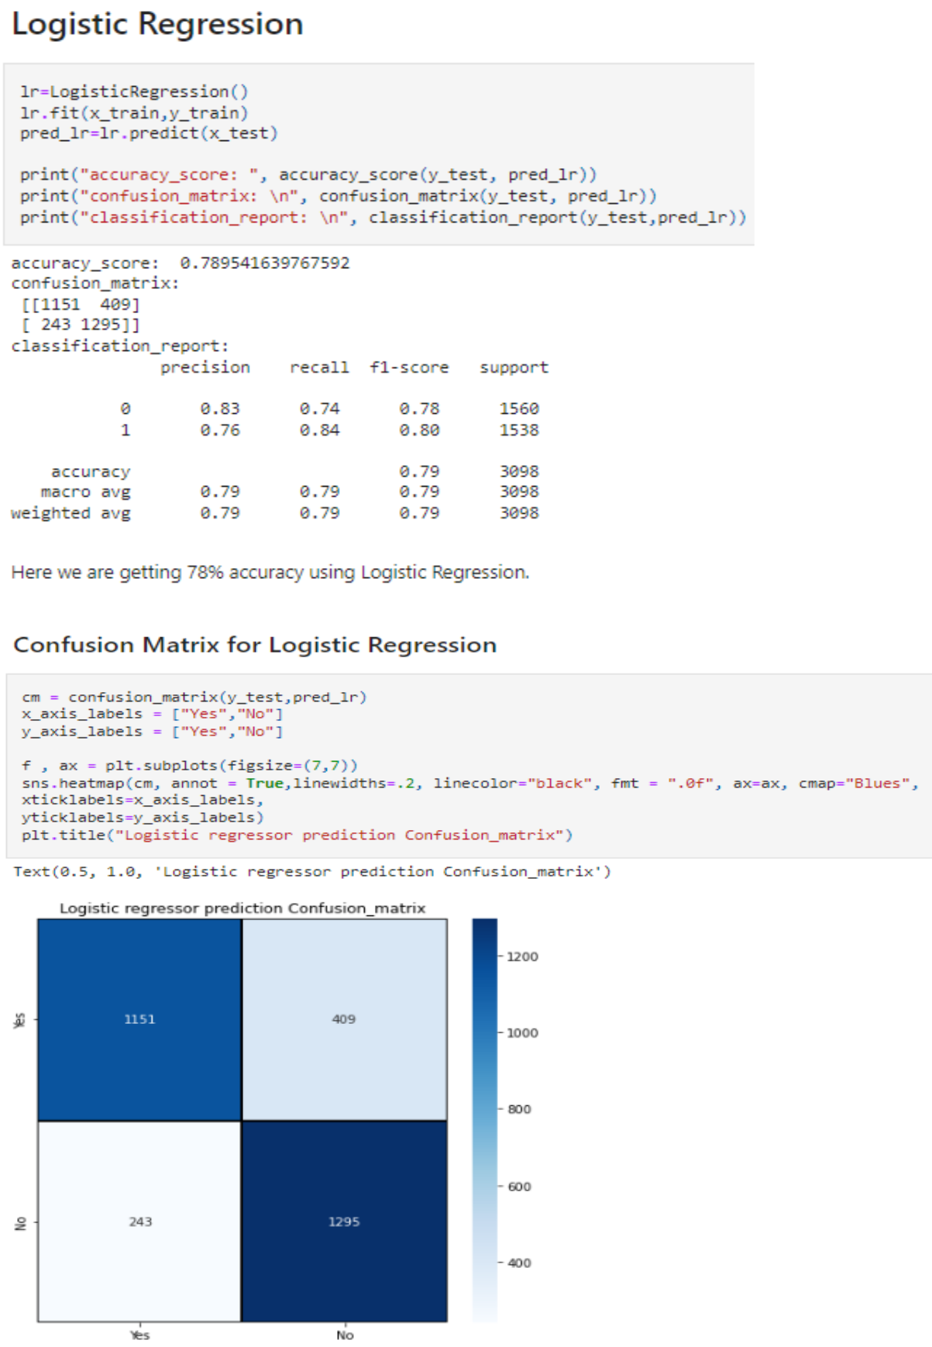

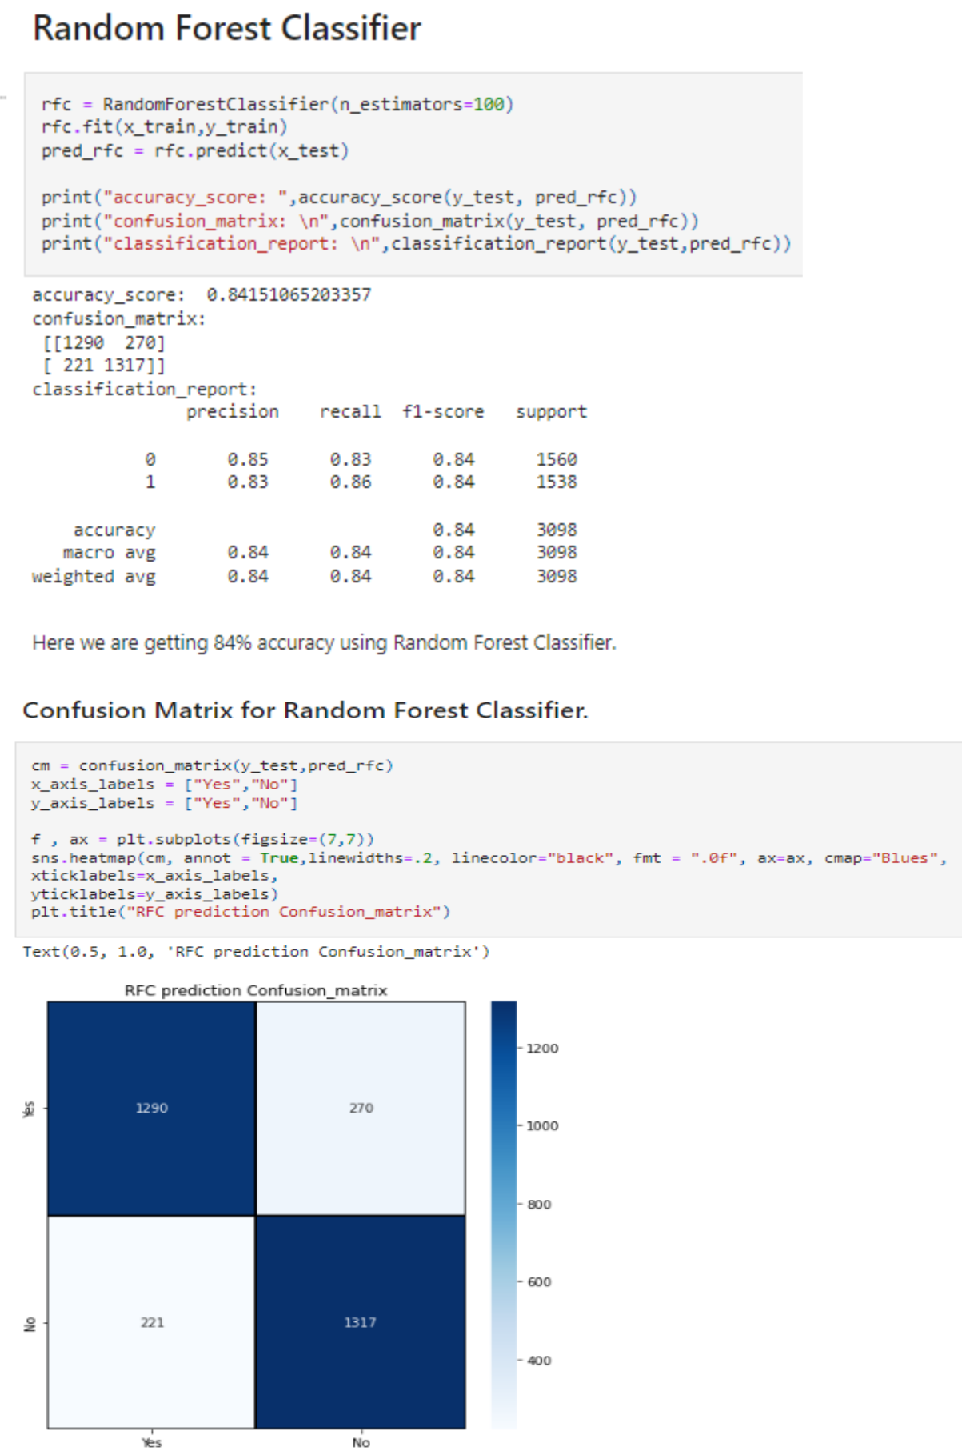

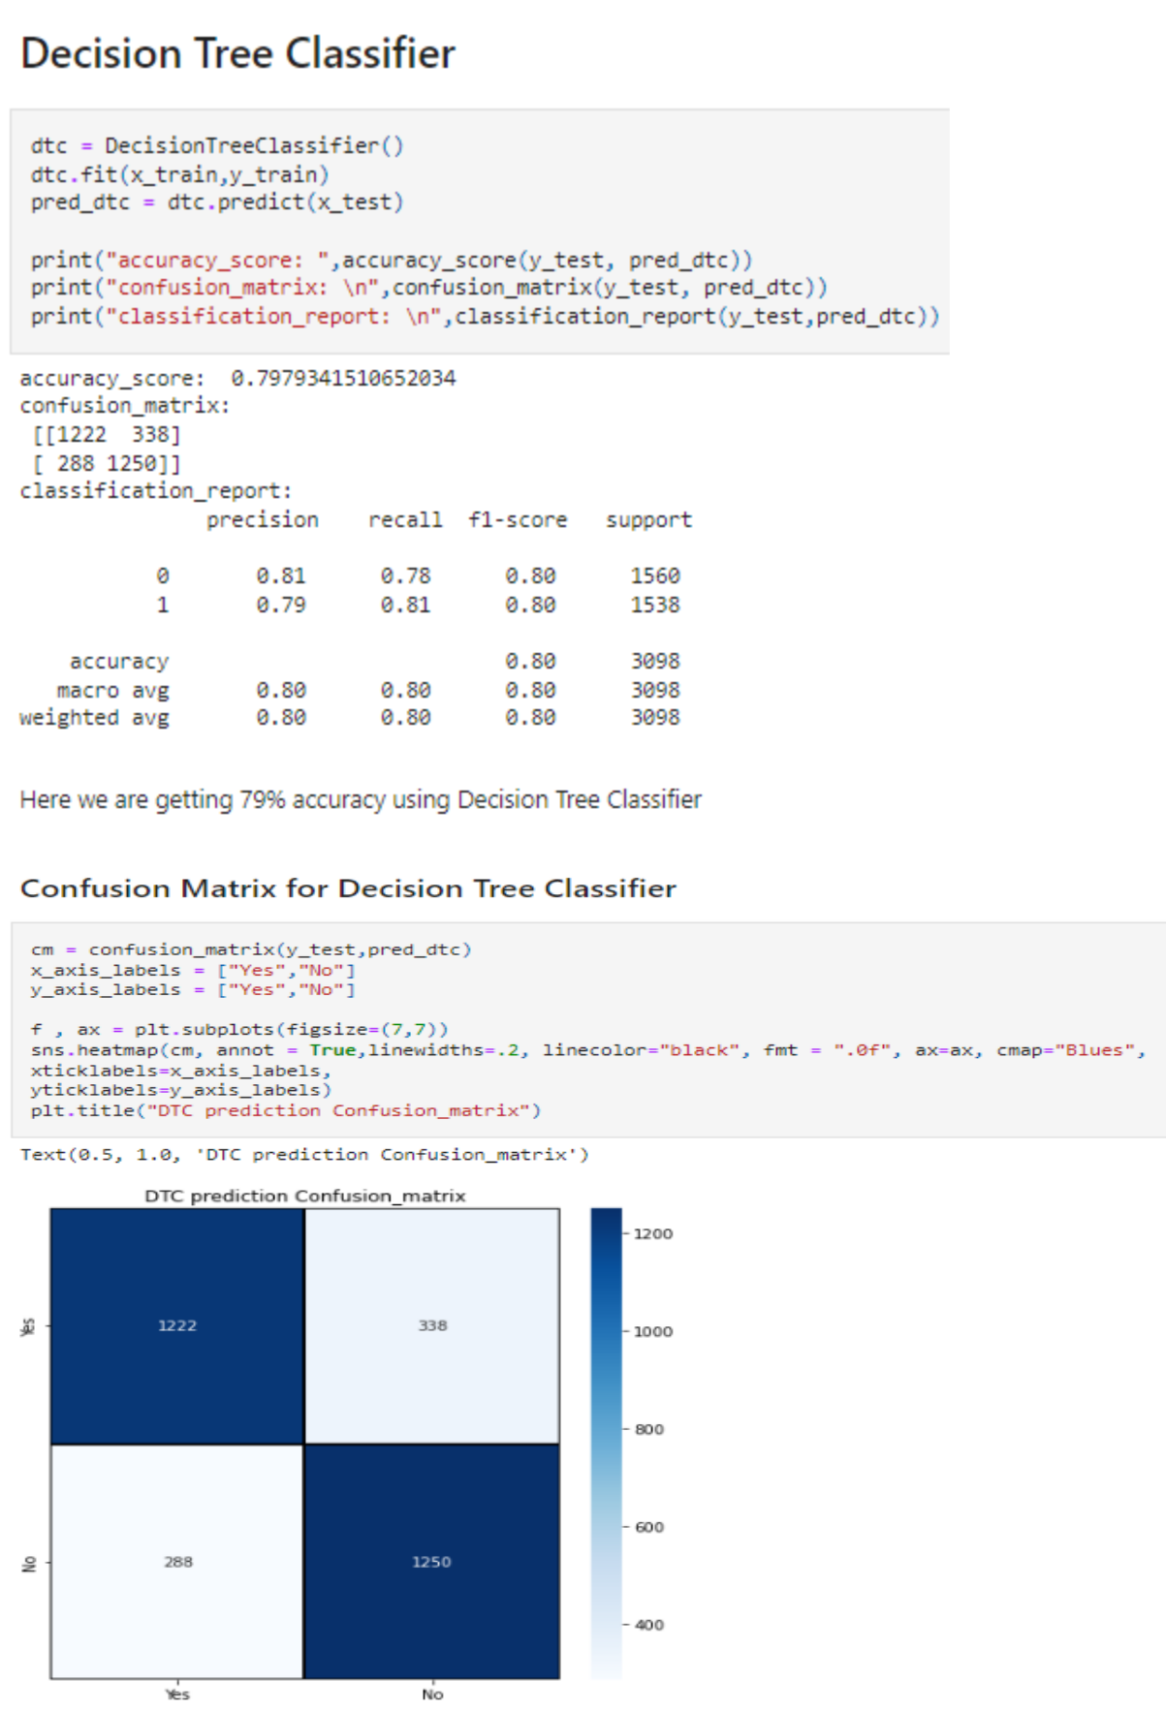

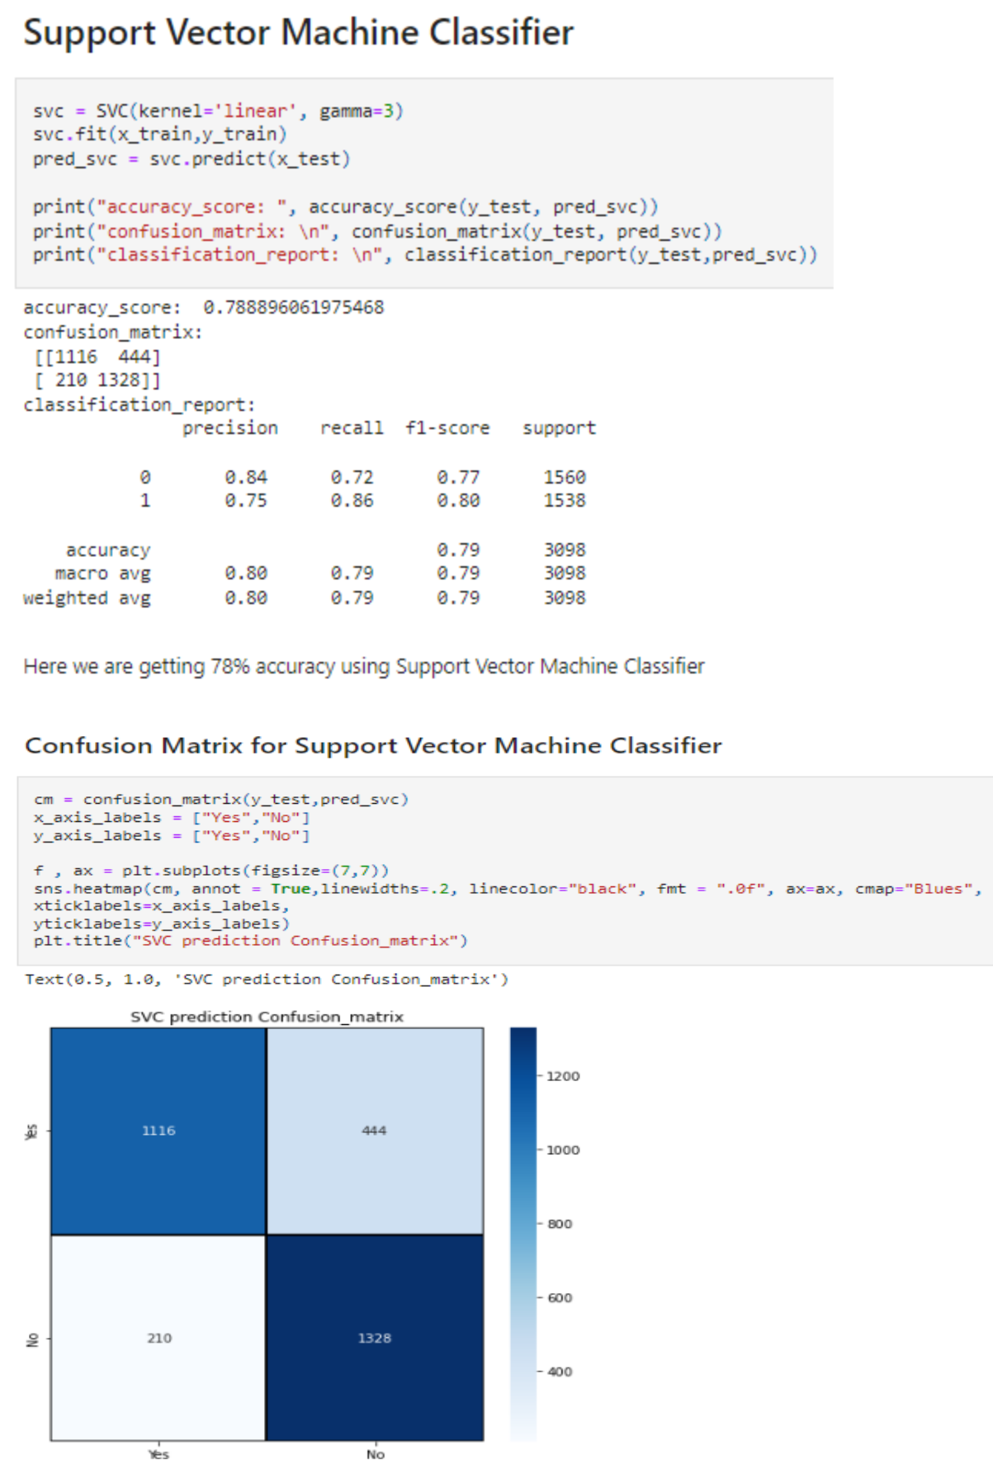

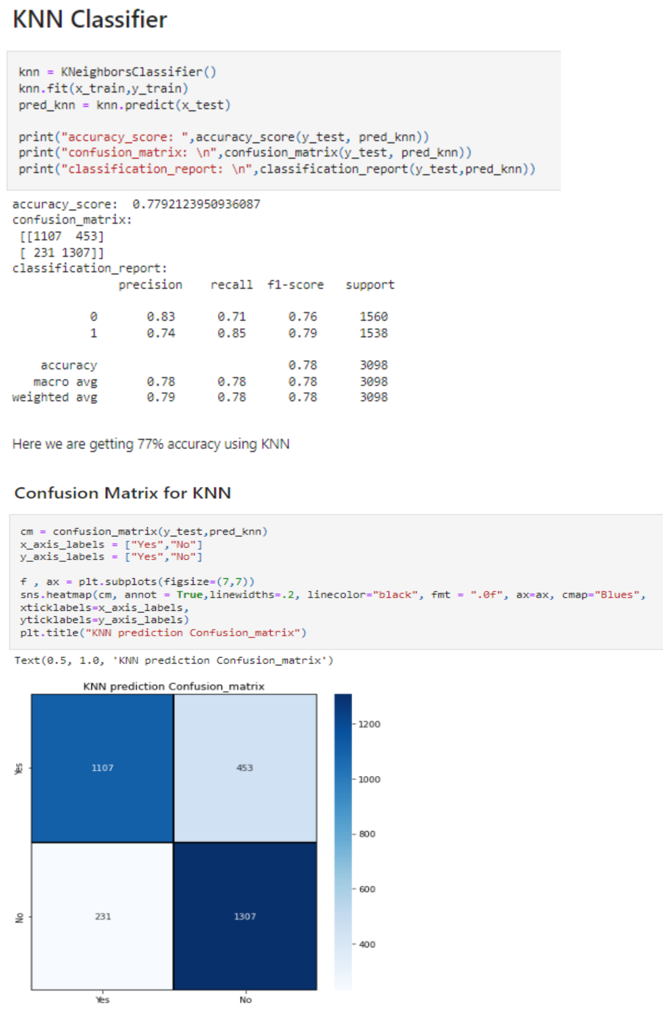

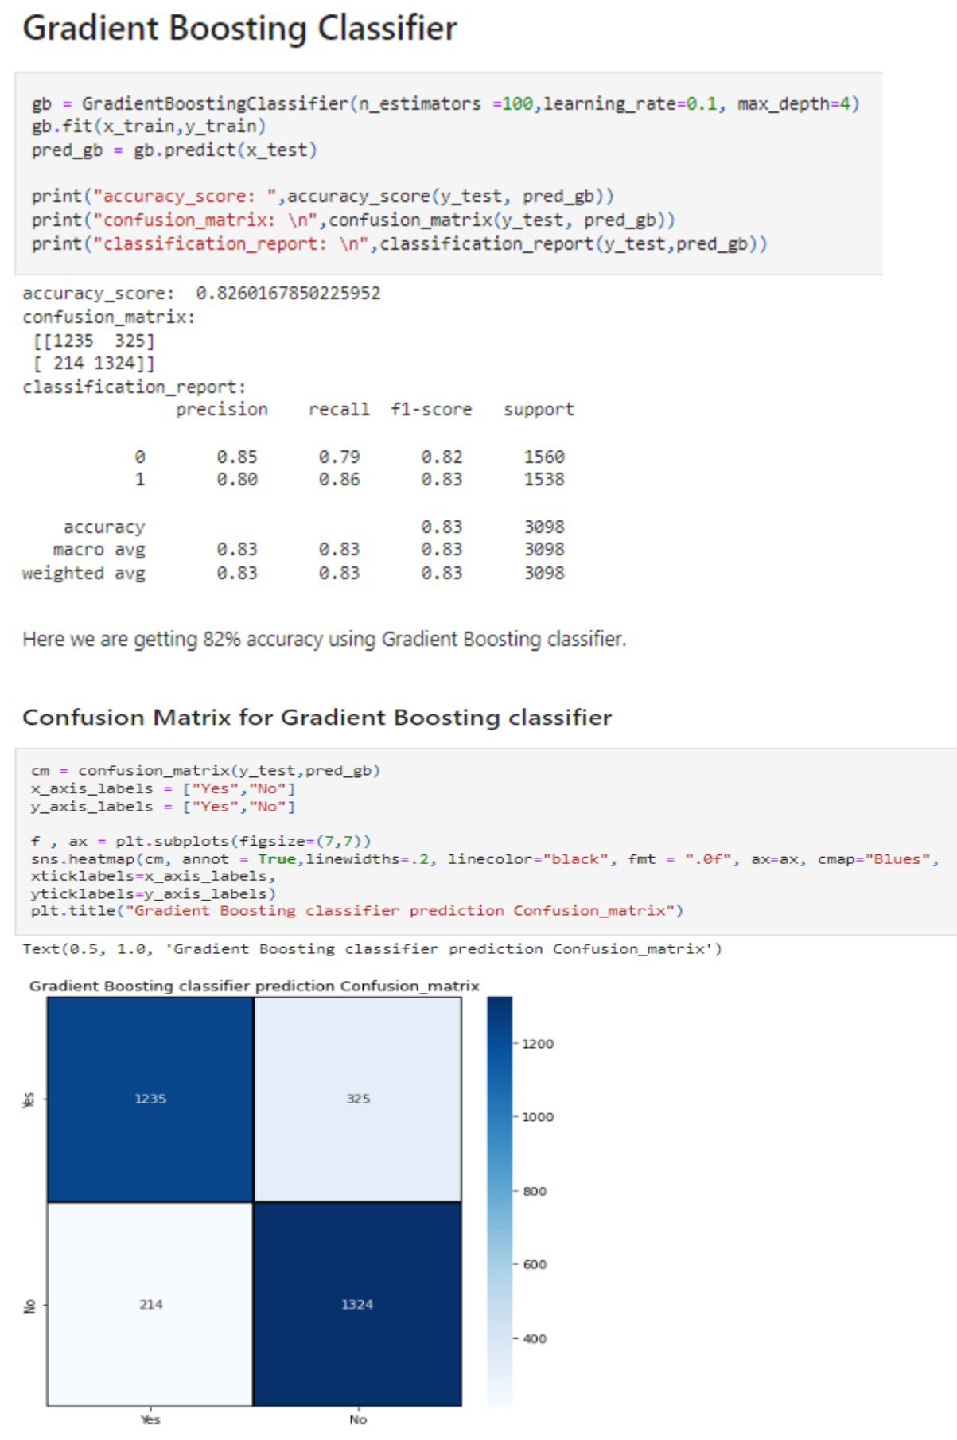

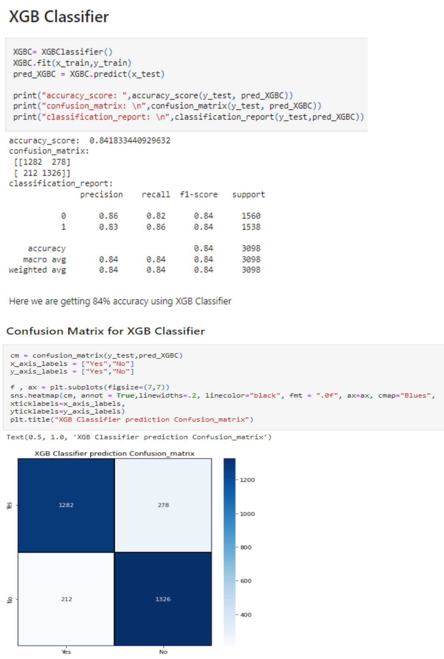

* **Cross Validation Score for all the model**

Cross-validation is primarily used in applied machine learning to estimate the skill of a machine learning model on unseen data. That is, to use a limited sample in order to estimate how the model is expected to perform in general when used to make predictions on data not used during the training of the model.

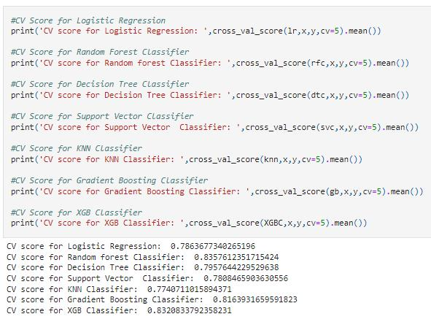

From the observation of accuracy and cross validation score and their difference we can predict that XGB Classifier is the best model.

* **ROC & AUC Curve for all model**

An ROC curve (receiver operating characteristic curve) is a graph showing the performance of a classification model at all classification thresholds. This curve plots two parameters:

* True Positive Rate
* False Positive Rate

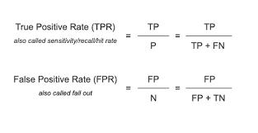

An ROC curve plots TPR vs. FPR at different classification thresholds. Lowering the classification threshold classifies more items as positive, thus increasing both False Positives and True Positives.

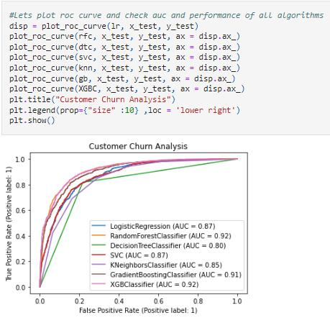

* **Hyper parameter tuning**

Models can have many hyperparameters and finding the best combination of parameters can be treated as a search problem. These parameters express important properties of the model such as its complexity or how fast it should learn. The two best strategies for Hyperparameter tuning are:

* GridSearchCV
* RandomizedSearchCV

* **GridSearchCV**

In GridSearchCV approach, the machine learning model is evaluated for a range of hyperparameter values. This approach is called GridSearchCV, because it searches for the best set of hyperparameters from a grid of hyperparameters values. We will use this hyperparameters for tuning the data.

**Drawback of GridSearchCV:** It go through all the intermediate combinations of hyperparameters which makes grid search computationally very expensive.

* **RandomizedSearchCV**

RandomizedSearchCV solves the drawbacks of GridSearchCV, as it goes through only a fixed number of hyperparameter settings. It moves within the grid in a random fashion to find the best set of hyperparameters. This approach reduces unnecessary computation.

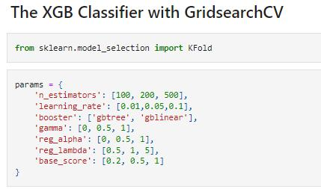

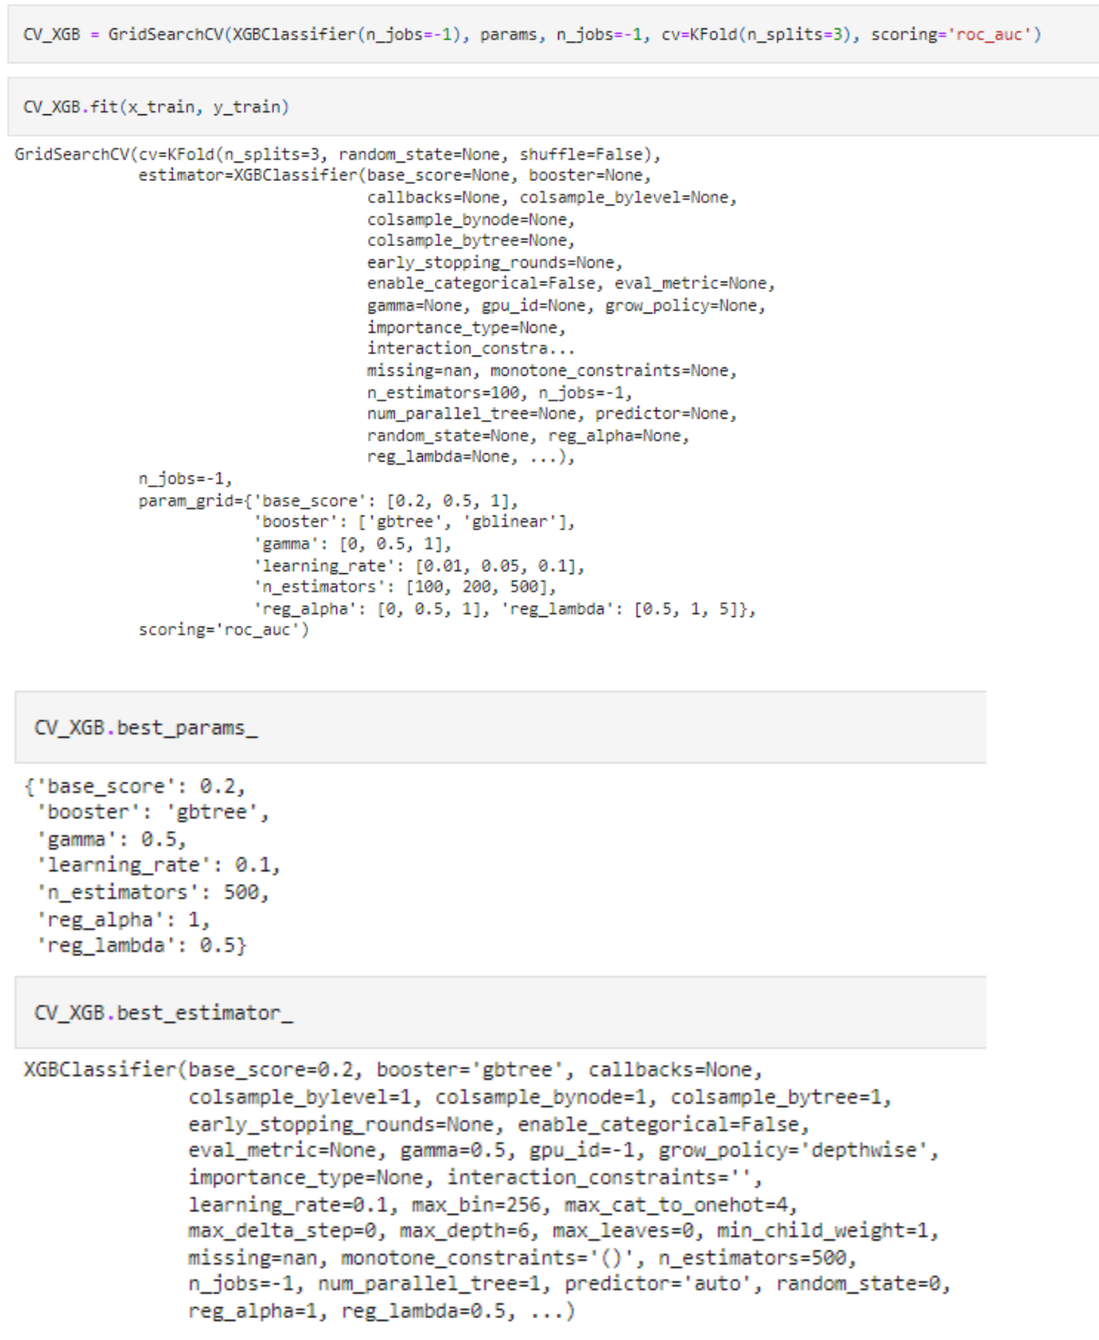

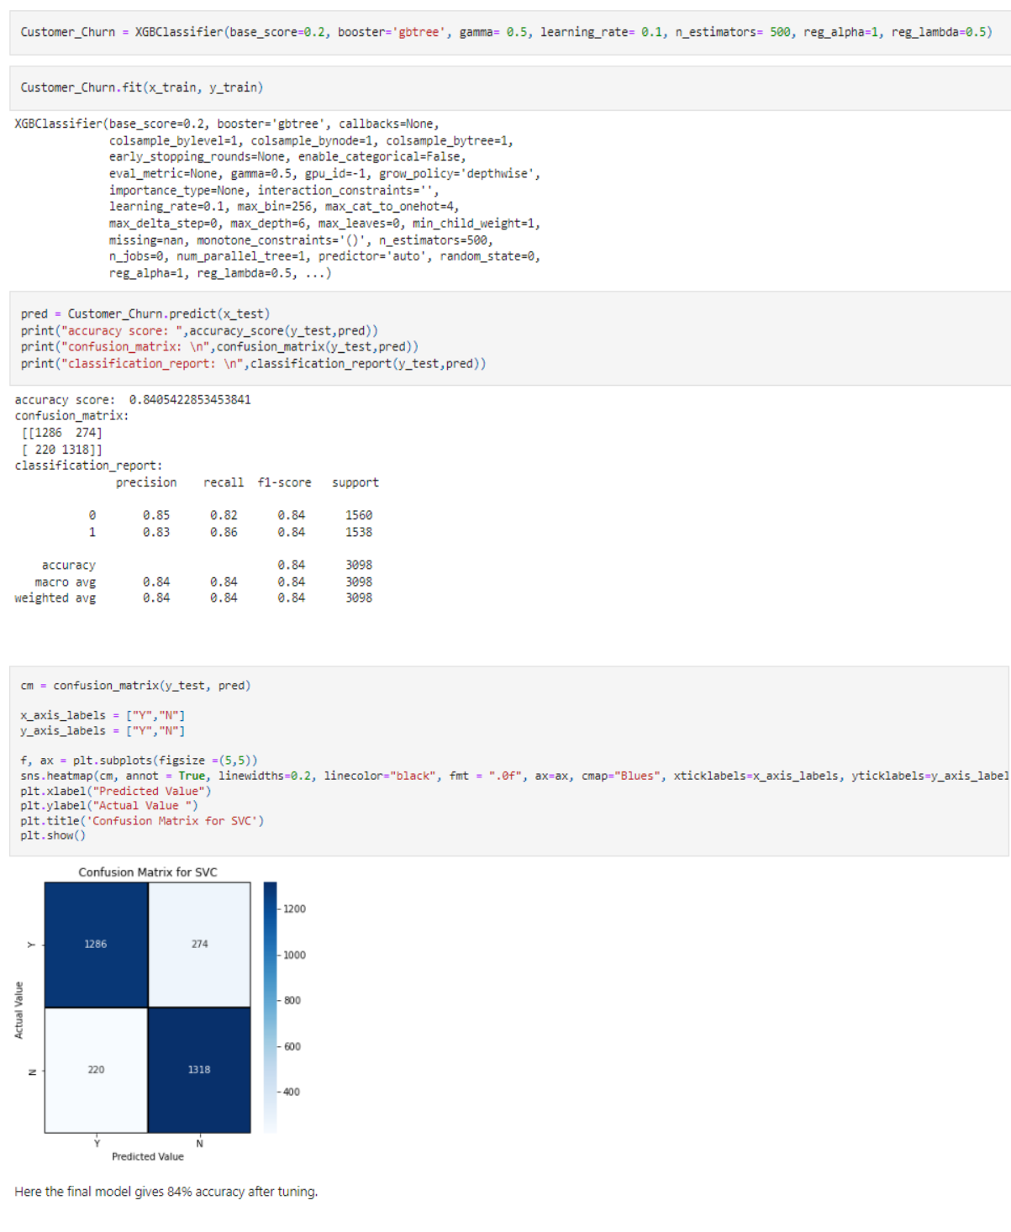

The final model gives 84% accuracy after tuning and will plot ROC-AUC curve for best model.

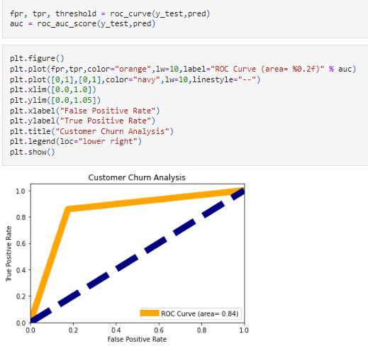

This is the AUC-ROC curve for the models which is plotted False positive rate against True positive rate. So, the best model has the area under curve as 0.84.

We got our best model so will save this model and will do Prediction.

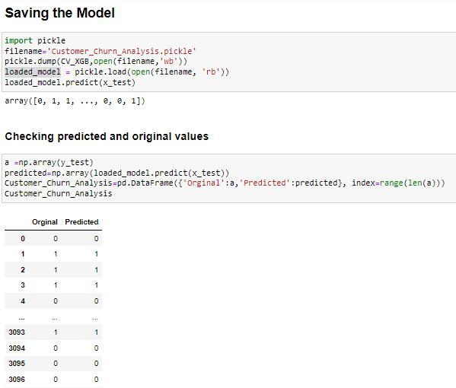

Finally, we can see, predicted and original values matches approx. 100%. So, we will save this model in csv.

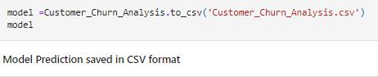

1. **Concluding Remarks**

Churn rate is an important indicator for companies. So, we need to:

* Analyse churn to improve customer service team.
* Revamp onboarding plan for new customers.
* Invest in more training for support and sales reps.
* Ask for feedback at key moments and respond promptly.
* Communicate proactively with customers.
* Offer exclusive perks to existing customers.
* Leverage feedback from free trial customers.
* To Reduce Customer Churn:
  + Focus attention on best customers.
  + Analyze Churn as it Occurs.
  + Show Customers that we care.

**Disclaimer**

I am new comer here in data science domain with some knowledge of 9 month. I have shared my effort in this blog to someone who is stepping in this field and can take some advantage from it. But to be honest it’s definitely inspired by others; I saw many blogs of this project on internet who have worked on this project before I just went through each of project and concluded my best way to make this blog.

